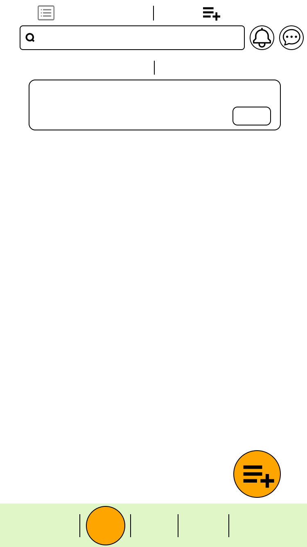

|  |
| --- |
| 抽獎 |

|  |
| --- |
| 問卷 |

|  |
| --- |
| 首頁 |

|  |
| --- |
| 活動 |

|  |
| --- |
| 我的 |

|  |
| --- |
| 請輸入關鍵字 |

|  |
| --- |
| 問卷列表 |

|  |
| --- |
| 問卷管理 |

|  |
| --- |
| 已發布問卷 |

|  |
| --- |
| 已結束問卷 |

|  |
| --- |
| 台科專題問卷 |

|  |
| --- |
| B10809025 / 張三 |

|  |
| --- |
| #抽獎#2分鐘#限男 |

|  |
| --- |
| 刪除 |

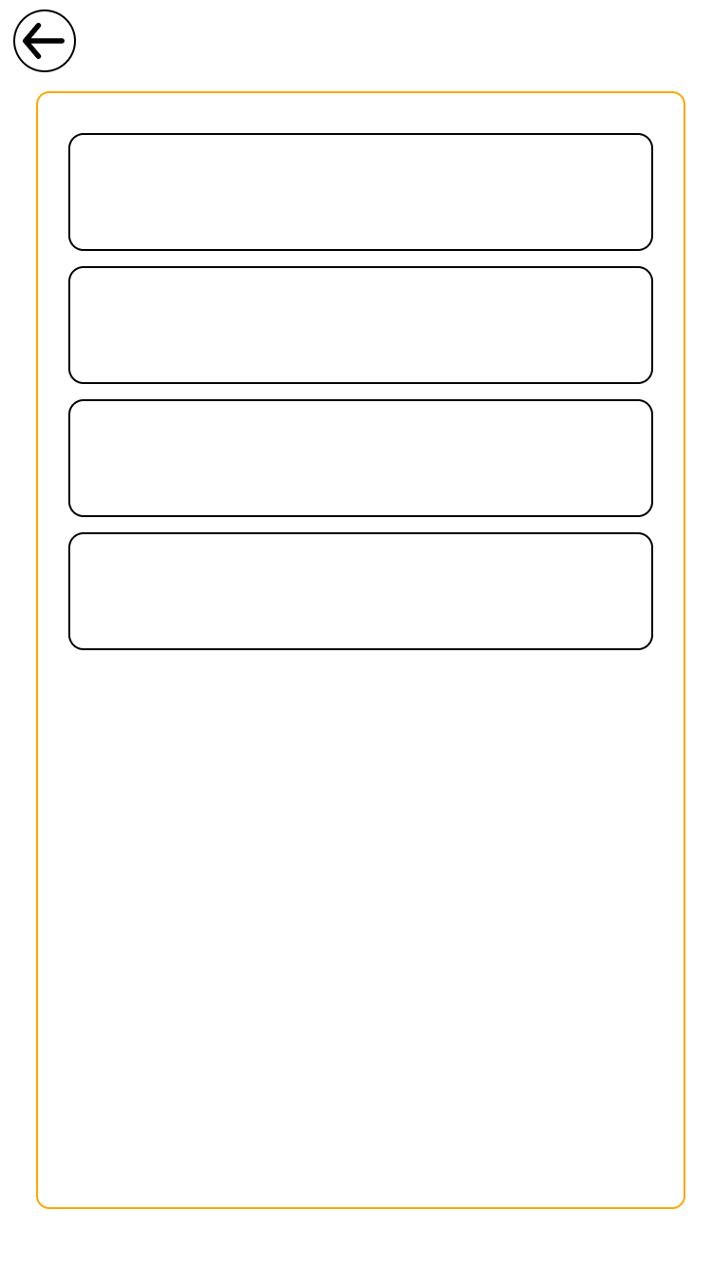

|  |
| --- |
| 聖誕舞會須知 |

|  |
| --- |
| #舞會#台科 |

|  |
| --- |
| 應外之夜活動取消 |

|  |
| --- |
| #表演#台科 |

|  |
| --- |
| 8小時前傳送 |

|  |
| --- |
| 16小時前傳送 |

|  |
| --- |
| 聖誕舞會須知 |

|  |
| --- |
| #舞會#台科 |

|  |
| --- |
| 應外之夜活動取消 |

|  |
| --- |
| #表演#台科 |

|  |
| --- |
| 8小時前傳送 |

|  |
| --- |
| 16小時前傳送 |

|  |
| --- |
| 通知 |

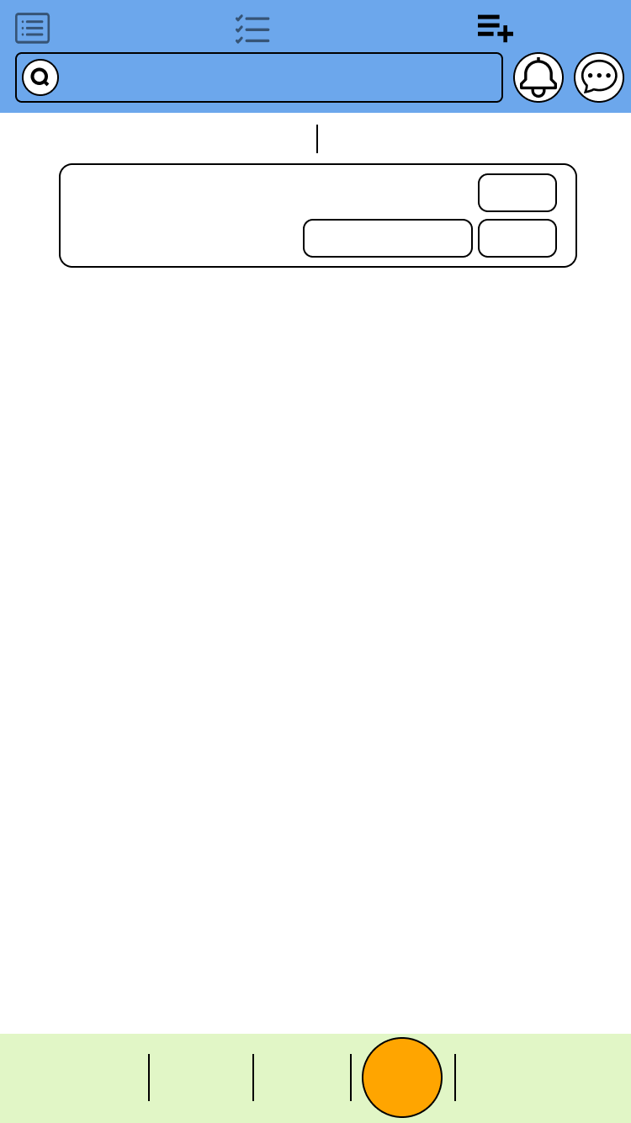A

|  |
| --- |
| 活動列表 |

|  |
| --- |
| 已報名活動 |

|  |
| --- |
| 活動管理 |

|  |
| --- |
| 請輸入關鍵字 |

|  |
| --- |
| 已發布活動 |

|  |
| --- |
| 已結束活動 |

|  |
| --- |
| 資管宿營 |

|  |
| --- |
| 台科資管系學會 |

|  |
| --- |
| #系務#台科 |

|  |
| --- |
| 報名者回報 |

|  |
| --- |
| 刪除 |

|  |
| --- |
| 詳細 |

|  |
| --- |
| 抽獎 |

|  |
| --- |
| 問卷 |

|  |
| --- |
| 首頁 |

|  |
| --- |
| 活動 |

|  |
| --- |
| 我的 |

|  |
| --- |
| 抽獎 |

|  |
| --- |
| 問卷 |

|  |
| --- |
| 首頁 |

|  |
| --- |
| 我的 |



|  |
| --- |
| 與對方已經是好友了 |

|  |
| --- |
| 確認 |



|  |
| --- |
| 已發送好友邀請 |

|  |
| --- |
| 確認 |



|  |
| --- |
| 恭喜中獎  請至兌換頁面確認 |

|  |
| --- |
| 確認 |



|  |
| --- |
| 使用規範  1.此卷僅限於在台科使用  2.XXXXXXXXXXX |

|  |
| --- |
| 確定 |



|  |
| --- |
| 沒抽中呢  請再接再勵 |

|  |
| --- |
| 確認 |



|  |
| --- |
| 確認要兌換  「嚴茶第二杯折五元」嗎? |

|  |
| --- |
| 取消 |

|  |
| --- |
| 確認兌換 |

|  |
| --- |
| ( 此頁面僅提供給商家使用 ) |



|  |
| --- |
| 確認要刪除「台科專題問卷」問卷嗎? |

|  |
| --- |
| 取消 |

|  |
| --- |
| 確認刪除 |



|  |
| --- |
| 密碼輸入錯誤  請再次確認 |

|  |
| --- |
| 確認 |



|  |
| --- |
| 確認要剔除「薄鹽」嗎? |

|  |
| --- |
| 取消 |

|  |
| --- |
| 確認刪除 |



|  |
| --- |
| 確認要刪除「資管宿營」活動嗎? |

|  |
| --- |
| 取消 |

|  |
| --- |
| 確認刪除 |

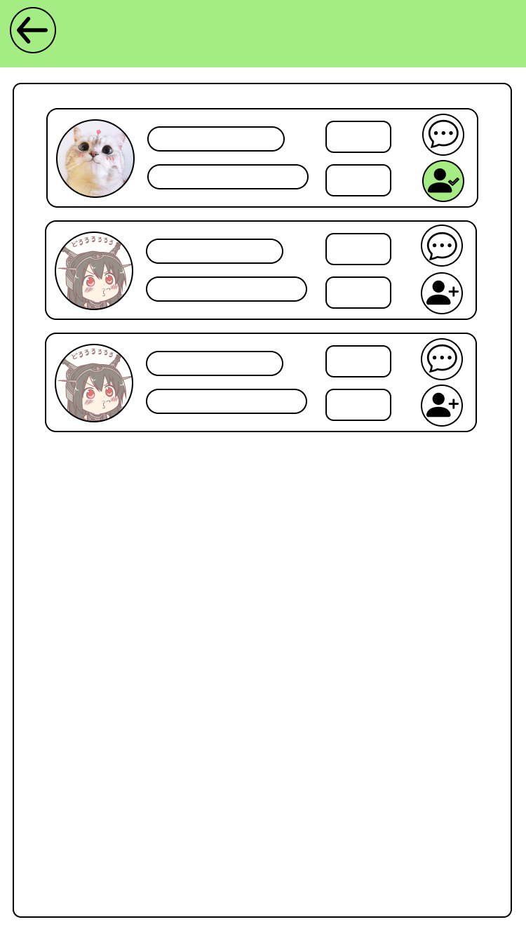

|  |
| --- |
| 已結束活動 |

|  |
| --- |
| B10809029 / 薄鹽 |

|  |
| --- |
| #台科#資管#學士#男 |

|  |
| --- |
| 評鑑 |

|  |
| --- |
| 詳細 |

|  |
| --- |
| B10809028 / 加號 |

|  |
| --- |
| #台科#資管#學士#男 |

|  |
| --- |
| B10809028 / 加號 |

|  |
| --- |
| #台科#資管#學士#男 |

|  |
| --- |
| 評鑑 |

|  |
| --- |
| 詳細 |

|  |
| --- |
| 評鑑 |

|  |
| --- |
| 詳細 |

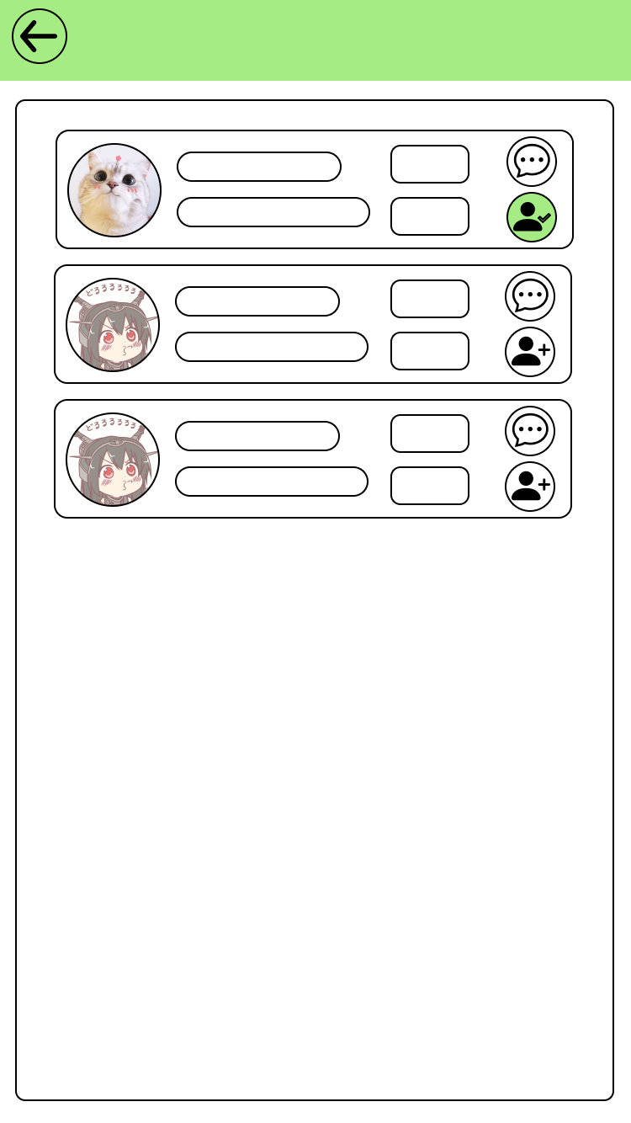

|  |
| --- |
| 已發布活動 |

|  |
| --- |
| B10809029 / 薄鹽 |

|  |
| --- |
| #台科#資管#學士#男 |

|  |
| --- |
| 踢出 |

|  |
| --- |
| 詳細 |

|  |
| --- |
| B10809028 / 加號 |

|  |
| --- |
| #台科#資管#學士#男 |

|  |
| --- |
| B10809028 / 加號 |

|  |
| --- |
| #台科#資管#學士#男 |

|  |
| --- |
| 踢出 |

|  |
| --- |
| 詳細 |

|  |
| --- |
| 踢出 |

|  |
| --- |
| 詳細 |

|  |
| --- |
| B10809028 / 加號 |

|  |
| --- |
| #台科#資管#學士#男 |

|  |
| --- |
| B10809028 / 加號 |

|  |
| --- |
| #台科#資管#學士#男 |

|  |
| --- |
| 踢出 |

|  |
| --- |
| 詳細 |

|  |
| --- |
| 踢出 |

|  |
| --- |
| 詳細 |

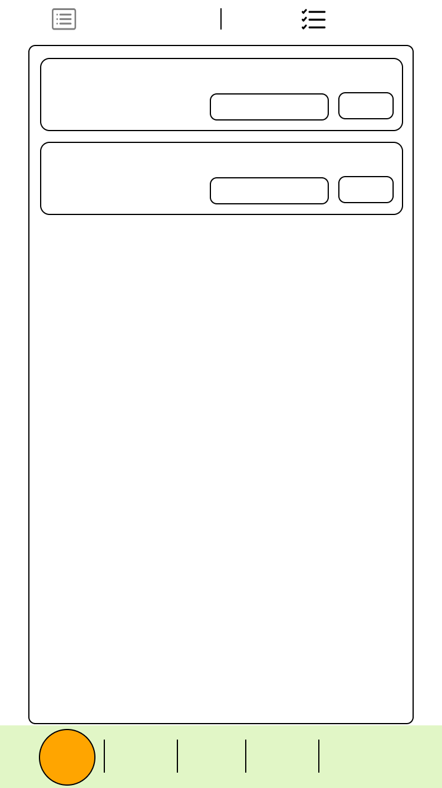

|  |
| --- |
| 抽獎 |

|  |
| --- |
| 問卷 |

|  |
| --- |
| 首頁 |

|  |
| --- |
| 活動 |

|  |
| --- |
| 我的 |

|  |
| --- |
| 抽獎 |

|  |
| --- |
| 抽獎列表 |

|  |
| --- |
| 兌換 |

|  |
| --- |
| 嚴茶第二杯折五元 |

|  |
| --- |
| 剩餘張數 : 3 |

|  |
| --- |
| 兌換 |

|  |
| --- |
| 使用期限 : 9 / 10 |

|  |
| --- |
| ( 詳細規範 ) |

|  |
| --- |
| MOS 折價卷 |

|  |
| --- |
| 剩餘張數 : 2 |

|  |
| --- |
| 兌換 |

|  |
| --- |
| 使用期限 : 9 / 10 |

|  |
| --- |
| ( 詳細規範 ) |

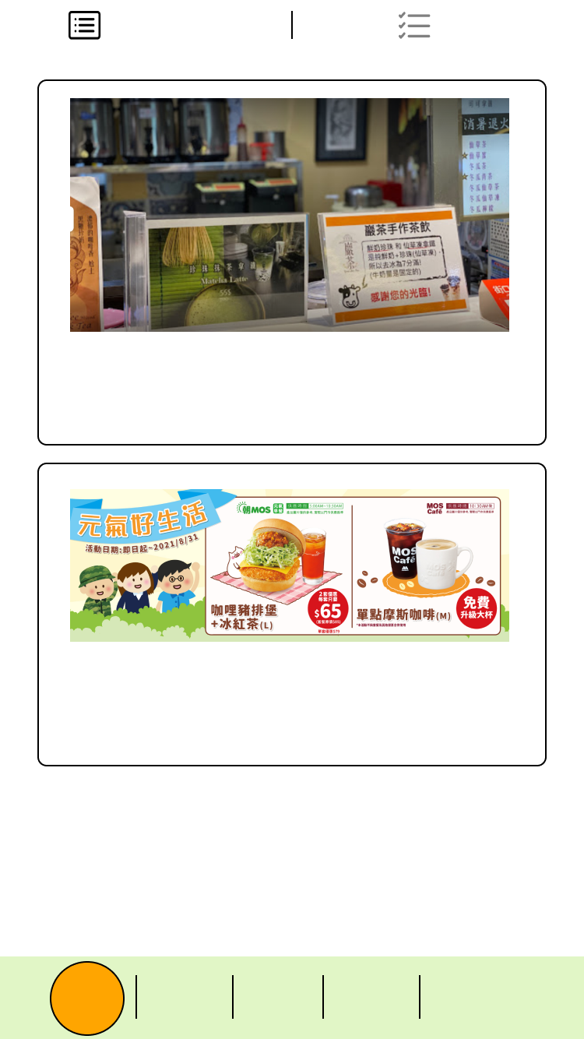

|  |
| --- |
| 嚴茶第二杯折五元 |

|  |
| --- |
| 使用期限 : 9 / 10 |

|  |
| --- |
| 剩餘張數 : 81 |

|  |
| --- |
| ( 詳細規範 ) |

|  |
| --- |
| ( 詳細規範 ) |

|  |
| --- |
| ( 抽獎 ) |

|  |
| --- |
| 機率 : 30% |

|  |
| --- |
| 冷卻時間 : 12 : 20 |

|  |
| --- |
| ( 抽獎 ) |

|  |
| --- |
| 機率 : 35% |

|  |
| --- |
| 冷卻時間 : 10 : 20 |

|  |
| --- |
| MOS 折價卷 |

|  |
| --- |
| 使用期限 : 9 / 10 |

|  |
| --- |
| 剩餘張數 : 81 |

|  |
| --- |
| 抽獎列表 |

|  |
| --- |
| 兌換 |

|  |
| --- |
| 抽獎 |

|  |
| --- |
| 問卷 |

|  |
| --- |
| 首頁 |

|  |
| --- |
| 活動 |

|  |
| --- |
| 我的 |

|  |
| --- |
| 抽獎 |

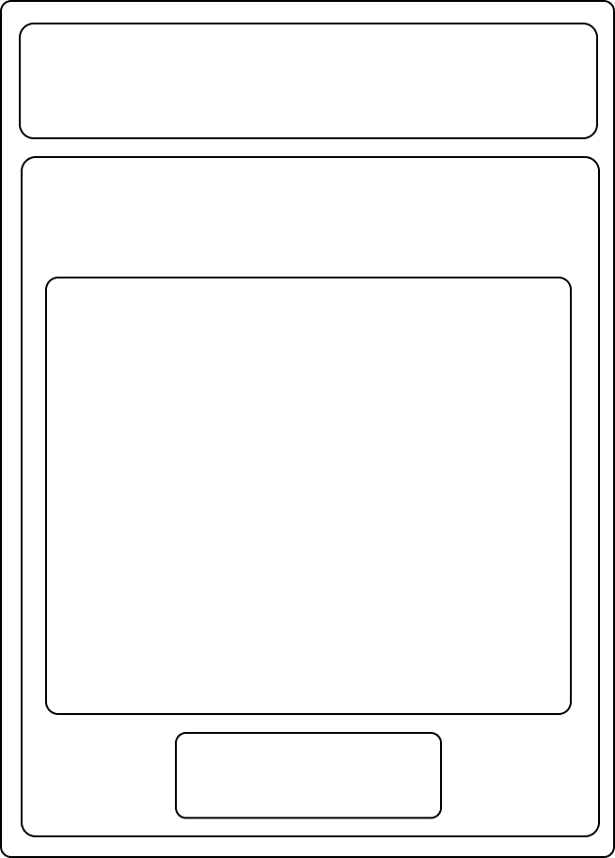

|  |
| --- |
| 取消原因 : |

|  |
| --- |
| 必填 |

|  |
| --- |
| 確認送出 |

|  |
| --- |
| 資管宿營 |

|  |
| --- |
| 台科資管系學會 |

|  |
| --- |
| #系務#台科 |

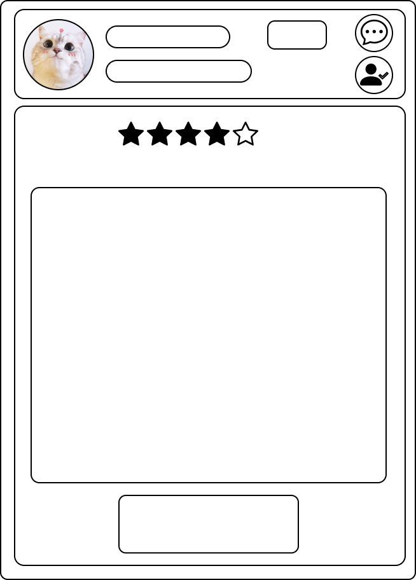

|  |
| --- |
| B10809029 / 薄鹽 |

|  |
| --- |
| #台科#資管#學士#男 |

|  |
| --- |
| 詳細 |
|  |

|  |
| --- |
| 配合度 : |

|  |
| --- |
| 回報原因 : |

|  |
| --- |
| 必填 |

|  |
| --- |
| 確認送出 |

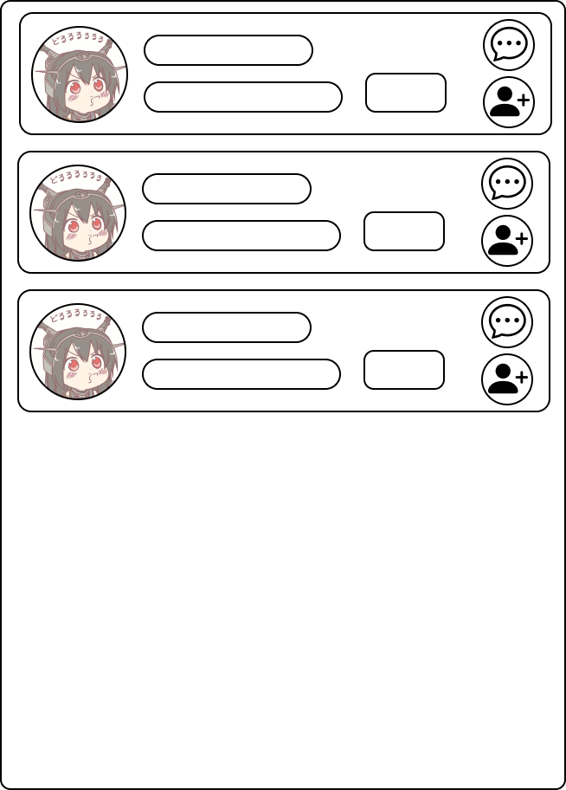

|  |
| --- |
| B10809028 / 加號 |

|  |
| --- |
| #台科#資管#學士#男 |

|  |
| --- |
| 詳細 |

|  |
| --- |
| B10809028 / 加號 |

|  |
| --- |
| #台科#資管#學士#男 |

|  |
| --- |
| 詳細 |

|  |
| --- |
| B10809028 / 加號 |

|  |
| --- |
| #台科#資管#學士#男 |

|  |
| --- |
| 詳細 |

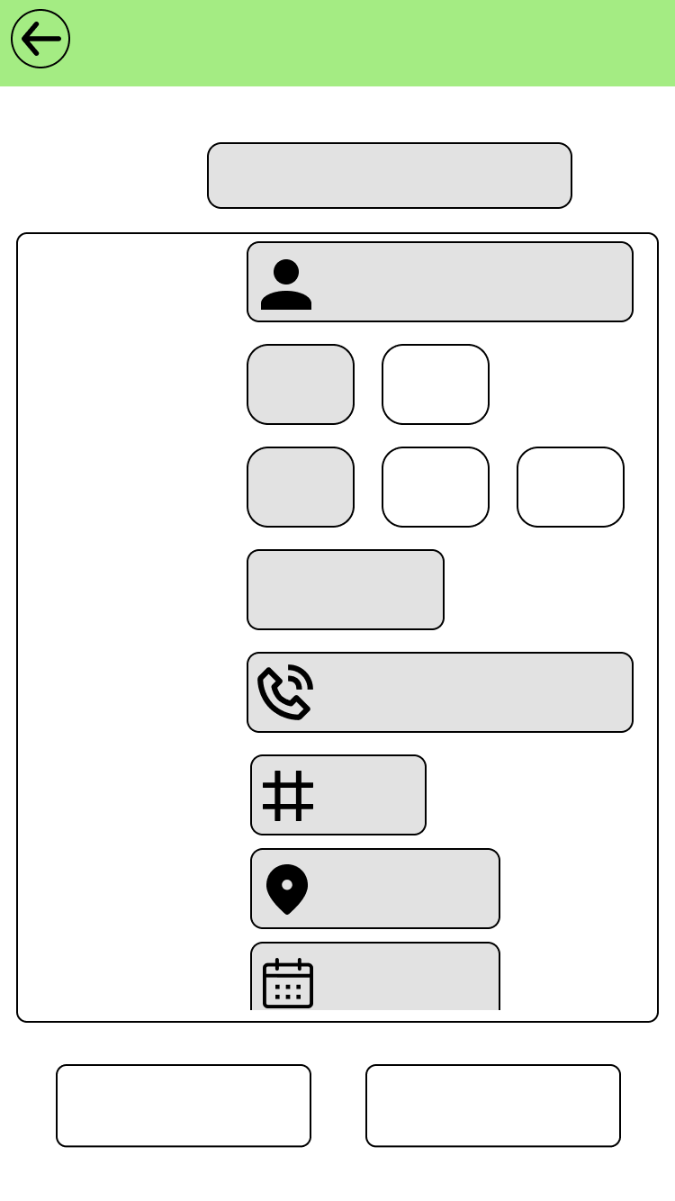

|  |
| --- |
| textview |

|  |
| --- |
| xx-xx-xx |

|  |
| --- |
| 活動日期 : |

|  |
| --- |
| 活動地點 : |

|  |
| --- |
|  |

|  |
| --- |
| num |

|  |
| --- |
| 限制人數 : |

|  |
| --- |
| 綁定自動輸入 |

|  |
| --- |
| 主辦 : |

|  |
| --- |
| 台科 |

|  |
| --- |
| 校別 : |

|  |
| --- |
| 台師 |

|  |
| --- |
| xxx-xxx-xxx |

|  |
| --- |
| 電話 : |

|  |
| --- |
| 自動填入 |

|  |
| --- |
| 年級 : |

|  |
| --- |
| 台大 |

|  |
| --- |
| 個人 |

|  |
| --- |
| 社團 : |

|  |
| --- |
| 社團 |

|  |
| --- |
| textview |

|  |
| --- |
| 名稱 : |

|  |
| --- |
| 修改資料 |

|  |
| --- |
| 確認送出 |

|  |
| --- |
| 活動發布 |

|  |
| --- |
|  |

|  |
| --- |
|  |

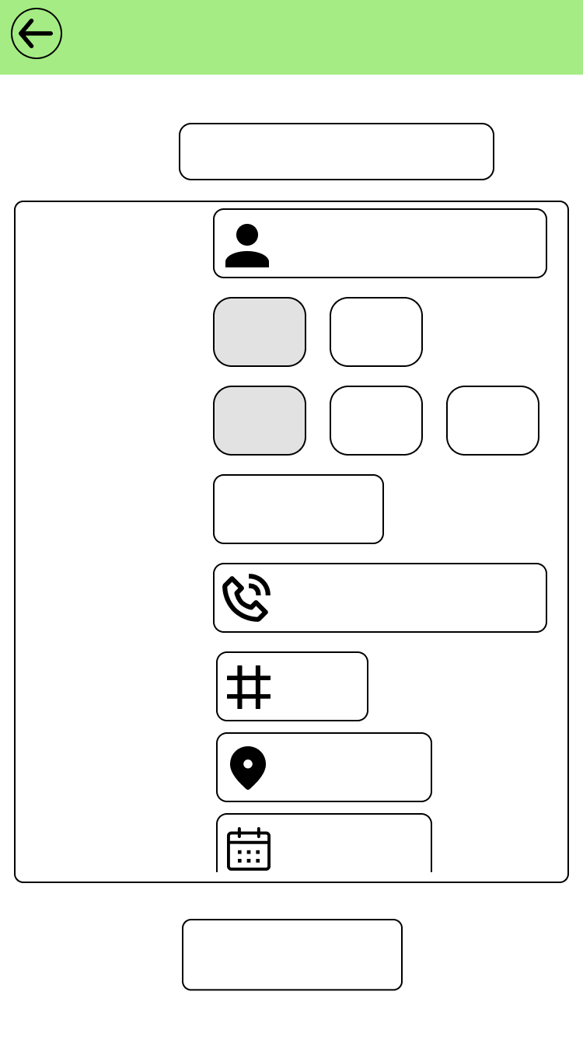

|  |
| --- |
|  |

|  |
| --- |
| textview |

|  |
| --- |
| xx-xx-xx |

|  |
| --- |
| 活動日期 : |

|  |
| --- |
| 活動地點 : |

|  |  |
| --- | --- |
| |  | | --- | |  | |

|  |
| --- |
| num |

|  |
| --- |
| 限制人數 : |

|  |
| --- |
| 綁定自動輸入 |

|  |
| --- |
| 主辦 : |

|  |
| --- |
| 台科 |

|  |
| --- |
| 校別 : |

|  |
| --- |
| 台師 |

|  |
| --- |
| xxx-xxx-xxx |

|  |
| --- |
| 電話 : |

|  |
| --- |
| 自動填入 |

|  |
| --- |
| 年級 : |

|  |
| --- |
| 台大 |

|  |
| --- |
| 個人 |

|  |
| --- |
| 社團 : |

|  |
| --- |
| 社團 |

|  |
| --- |
| textview |

|  |
| --- |
| 名稱 : |

|  |
| --- |
| 確認發布 |

|  |
| --- |
| 活動發布 |

|  |
| --- |
|  |

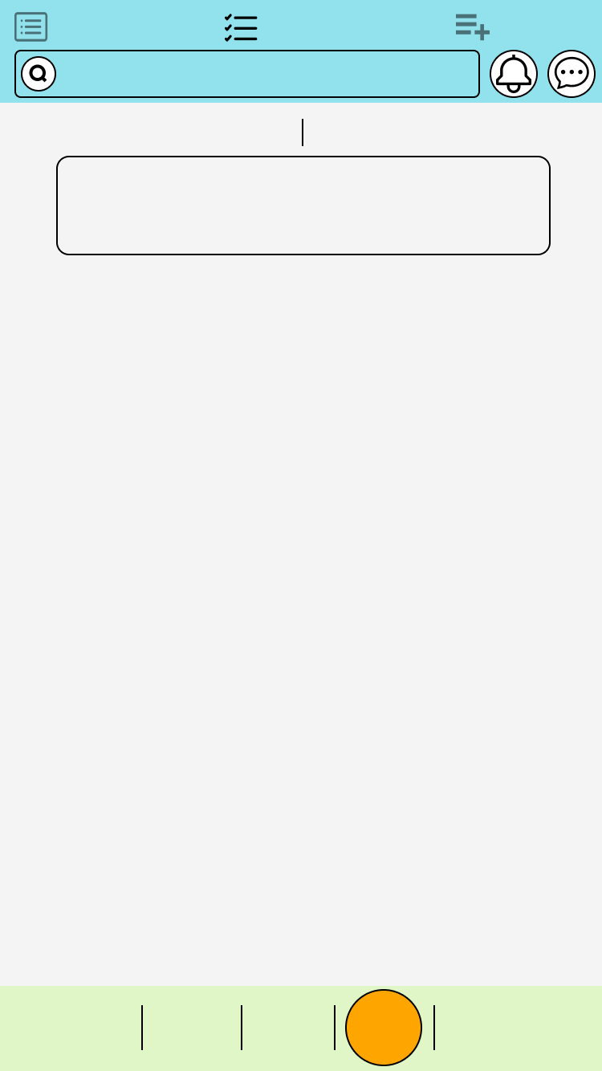

|  |
| --- |
| 尚未開始 |

|  |
| --- |
| 已結束 |

|  |
| --- |
| 台科開學典禮 |

|  |
| --- |
| 台科學生會 |

|  |
| --- |
| #校務#台科 |

|  |
| --- |
| 活動列表 |

|  |
| --- |
| 已報名活動 |

|  |
| --- |
| 活動管理 |

|  |
| --- |
| 請輸入關鍵字 |

|  |
| --- |
| 抽獎 |

|  |
| --- |
| 問卷 |

|  |
| --- |
| 首頁 |

|  |
| --- |
| 活動 |

|  |
| --- |
| 我的 |

|  |
| --- |
| 抽獎 |

|  |
| --- |
| 問卷 |

|  |
| --- |
| 首頁 |

|  |
| --- |
| 我的 |

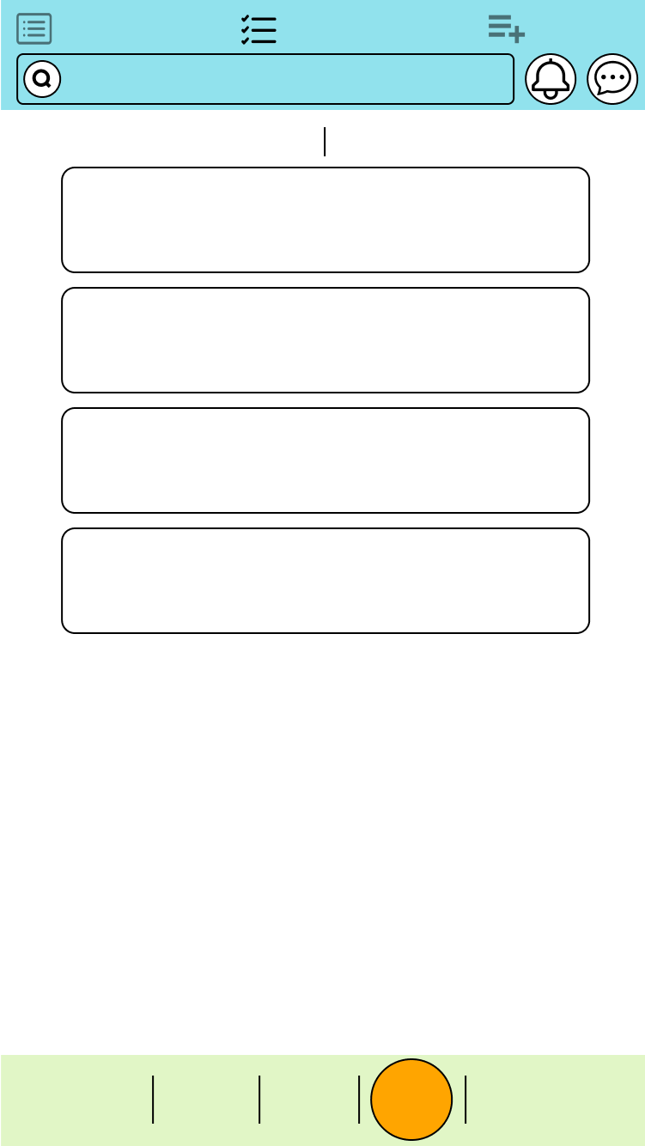

|  |
| --- |
| 尚未開始 |

|  |
| --- |
| 已結束 |

|  |
| --- |
| 台科貓貓募資救援 |

|  |
| --- |
| 台科根與芽 |

|  |
| --- |
| #吸貓#台科 |

|  |
| --- |
| 研究生募集 |

|  |
| --- |
| 渣老大 |

|  |
| --- |
| #實習#台科 |

|  |
| --- |
| 活動列表 |

|  |
| --- |
| 已報名活動 |

|  |
| --- |
| 活動管理 |

|  |
| --- |
| 請輸入關鍵字 |

|  |
| --- |
| 抽獎 |

|  |
| --- |
| 問卷 |

|  |
| --- |
| 首頁 |

|  |
| --- |
| 活動 |

|  |
| --- |
| 我的 |

|  |
| --- |
| 抽獎 |

|  |
| --- |
| 問卷 |

|  |
| --- |
| 首頁 |

|  |
| --- |
| 我的 |

|  |
| --- |
| 舉辦日期 : 8 / 7 |

|  |
| --- |
| 舉辦日期 : 8 / 8 |

|  |
| --- |
| 台科貓貓募資救援 |

|  |
| --- |
| 台科根與芽 |

|  |
| --- |
| #吸貓#台科 |

|  |
| --- |
| 研究生募集 |

|  |
| --- |
| 渣老大 |

|  |
| --- |
| #實習#台科 |

|  |
| --- |
| 舉辦日期 : 8 / 7 |

|  |
| --- |
| 舉辦日期 : 8 / 8 |

|  |
| --- |
|  |



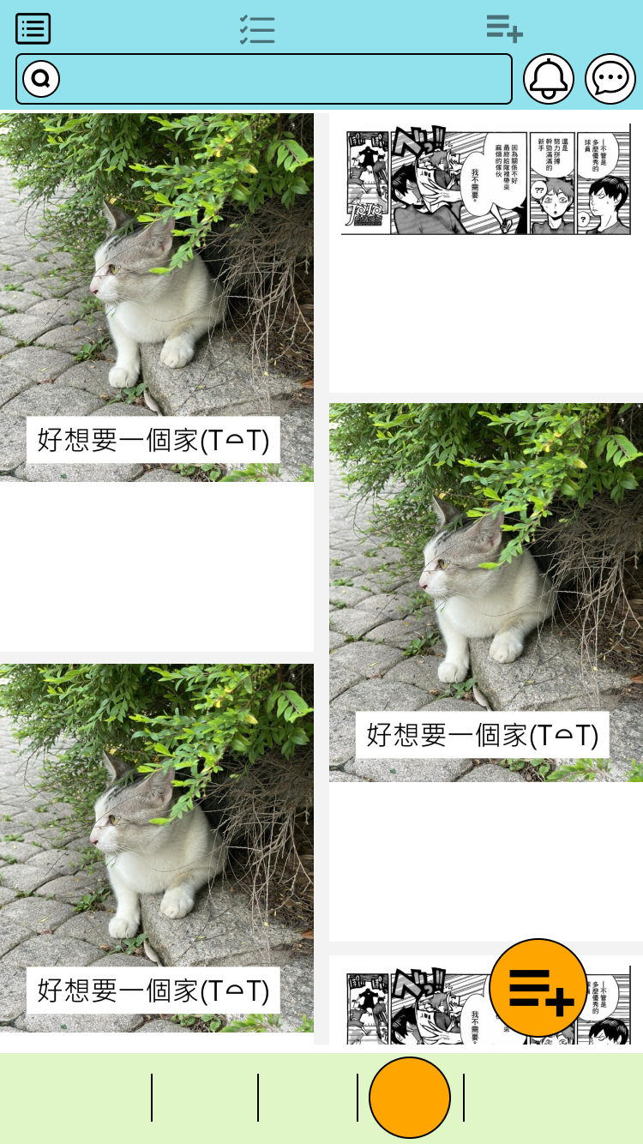

|  |
| --- |
| 研究生募集 |

|  |
| --- |
| 渣老大 |

|  |
| --- |
| #實習#台科 |

|  |
| --- |
| 台科貓貓募資救援 |

|  |
| --- |
| 台科根與芽 |

|  |
| --- |
| #吸貓#台科 |

|  |
| --- |
| 舉辦日期 : 8 / 8 |

|  |
| --- |
| 參與人數 : 12 / 20 |

|  |
| --- |
| 舉辦日期 : 8 / 7 |

|  |
| --- |
| 台科貓貓募資救援 |

|  |
| --- |
| 台科根與芽 |

|  |
| --- |
| #吸貓#台科 |

|  |
| --- |
| 參與人數 : 12 / 20 |

|  |
| --- |
| 舉辦日期 : 8 / 7 |

|  |
| --- |
| 參與人數 : 12 / 34 |

|  |
| --- |
|  |

|  |
| --- |
| 請輸入關鍵字 |

|  |
| --- |
| 活動列表 |

|  |
| --- |
| 已報名活動 |

|  |
| --- |
| 活動管理 |

|  |
| --- |
| 抽獎 |

|  |
| --- |
| 問卷 |

|  |
| --- |
| 首頁 |

|  |
| --- |
| 活動 |

|  |
| --- |
| 我的 |

|  |
| --- |
| 抽獎 |

|  |
| --- |
| 問卷 |

|  |
| --- |
| 首頁 |

|  |
| --- |
| 我的 |

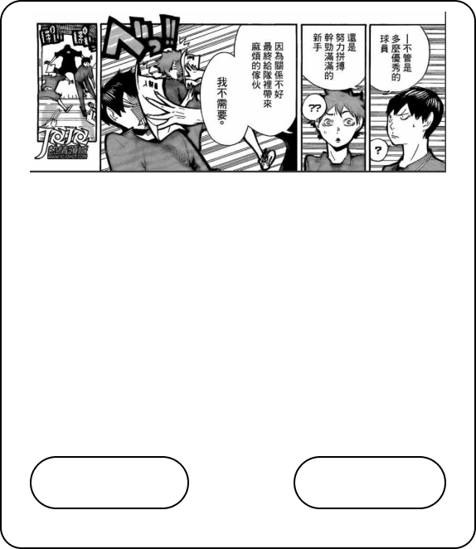

|  |
| --- |
| 研究生募集 |

|  |
| --- |
| #實習#台科 |

|  |
| --- |
| ( 附件資訊 ) |

|  |
| --- |
| 稱謂 : 台科資管教授 |

|  |
| --- |
| 地點 : 台灣科技大學 |

|  |
| --- |
| 時間 : 8/8 |

|  |
| --- |
| 取消報名 |

|  |
| --- |
| 人員列表 |

|  |
| --- |
| 參與人數 : 12 / 20 |



|  |
| --- |
| 研究生募集 |

|  |
| --- |
| #實習#台科 |

|  |
| --- |
| ( 附件資訊 ) |

|  |
| --- |
| 稱謂 : 台科資管教授 |

|  |
| --- |
| 地點 : 台灣科技大學 |

|  |
| --- |
| 時間 : 8/8 |

|  |
| --- |
| 立即報名 |

|  |
| --- |
| 參與人數 : 12 / 20 |

|  |
| --- |
| 人員列表 |

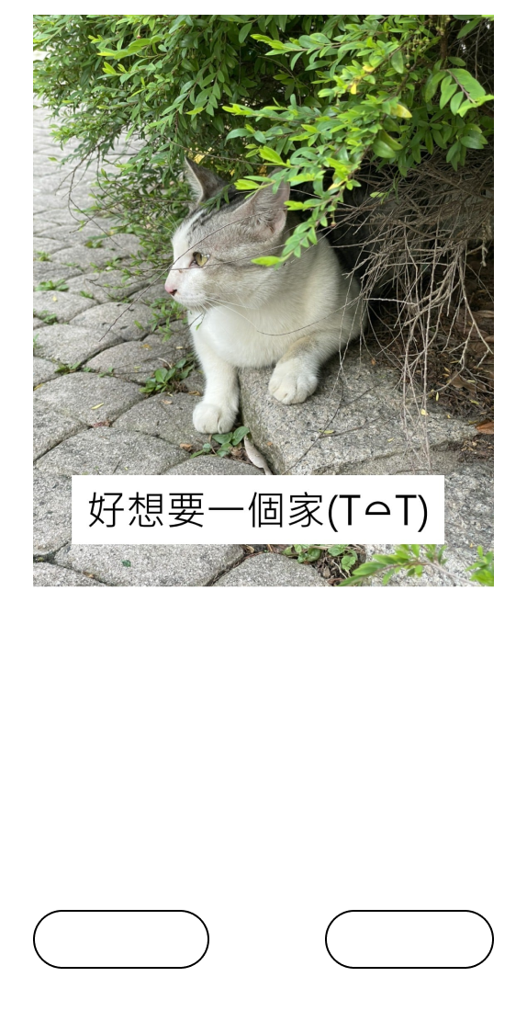

|  |
| --- |
| 台科貓貓募資救援 |

|  |
| --- |
| #吸貓#台科 |

|  |
| --- |
| ( 附件資訊 ) |

|  |
| --- |
| 社團 : 台科根與芽 |

|  |
| --- |
| 地點 : 台灣科技大學 |

|  |
| --- |
| 時間 : 8/8 |

|  |
| --- |
| 取消報名 |

|  |
| --- |
| 人員列表 |

|  |
| --- |
| 參與人數 : 12 / 20 |

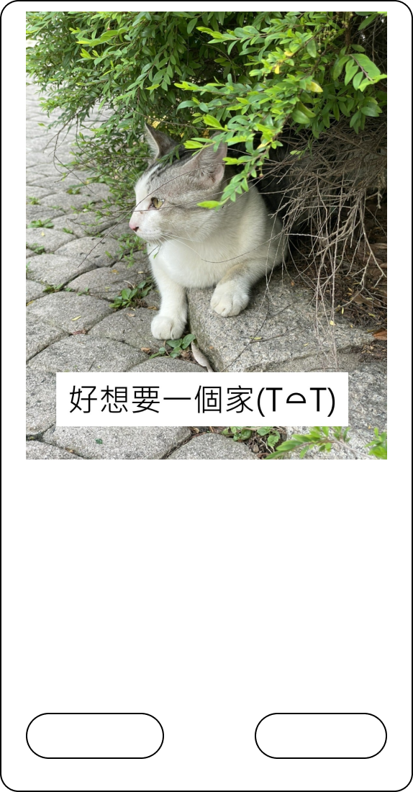

|  |
| --- |
| 台科貓貓募資救援 |

|  |
| --- |
| #吸貓#台科 |

|  |
| --- |
| ( 附件資訊 ) |

|  |
| --- |
| 社團 : 台科根與芽 |

|  |
| --- |
| 立即報名 |

|  |
| --- |
| 地點 : 台灣科技大學 |

|  |
| --- |
| 時間 : 8/8 |

|  |
| --- |
| 參與人數 : 12 / 20 |

|  |
| --- |
| 人員列表 |

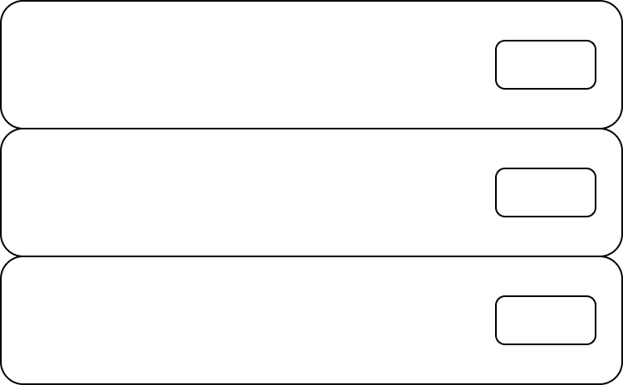

|  |
| --- |
| 主題 |

|  |
| --- |
| 主辦方 |

|  |
| --- |
| 校別 |

|  |
| --- |
| #實習#吸貓#交友#遊戲#比賽 |

|  |
| --- |
| #台科#台大#台師大 |

|  |
| --- |
| #兆豐銀行#教育部#警政署 |

|  |
| --- |
| 詳細 |

|  |
| --- |
| 詳細 |

|  |
| --- |
| 詳細 |

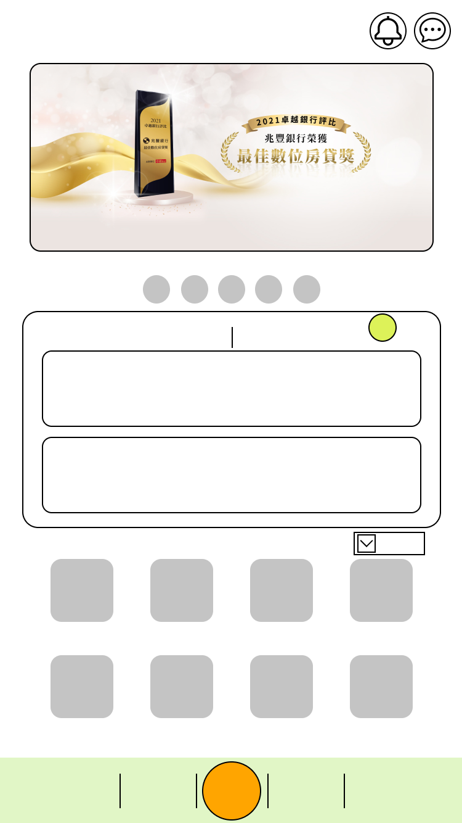

|  |
| --- |
| 聖誕舞會須知 |

|  |
| --- |
| #舞會#台科 |

|  |
| --- |
| 應外之夜活動取消 |

|  |
| --- |
| #表演#台科 |

|  |
| --- |
| 8小時前傳送 |

|  |
| --- |
| 16小時前傳送 |

|  |
| --- |
| 抽獎 |

|  |
| --- |
| 問卷 |

|  |
| --- |
| 首頁 |

|  |
| --- |
| 活動 |

|  |
| --- |
| 我的 |

|  |
| --- |
| 尚未開始活動 |

|  |
| --- |
| 通知 |

|  |
| --- |
| GPA |

|  |
| --- |
| #外部連結 |

|  |
| --- |
| 選課 |

|  |
| --- |
| 課程 |

|  |
| --- |
| 二手書 |

|  |
| --- |
| 地圖 |

|  |
| --- |
| 成績 |

|  |
| --- |
| 教室借用 |

|  |
| --- |
| 圖書館 |

|  |
| --- |
| 4 |

|  |
| --- |
| 台科 |



|  |
| --- |
| 台科貓貓募資救援 |

|  |
| --- |
| #吸貓#台科 |

|  |
| --- |
| 研究生募集 |

|  |
| --- |
| #實習#台科 |

|  |
| --- |
| 舉辦日期 : 8 / 7 |

|  |
| --- |
| 舉辦日期 : 8 / 8 |

|  |
| --- |
| 抽獎 |

|  |
| --- |
| 問卷 |

|  |
| --- |
| 首頁 |

|  |
| --- |
| 活動 |

|  |
| --- |
| 我的 |

|  |
| --- |
| 尚未開始活動 |

|  |
| --- |
| 通知 |

|  |
| --- |
| GPA |

|  |
| --- |
| #外部連結 |

|  |
| --- |
| 台科 |

|  |
| --- |
| 選課 |

|  |
| --- |
| 課程 |

|  |
| --- |
| 二手書 |

|  |
| --- |
| 地圖 |

|  |
| --- |
| 成績 |

|  |
| --- |
| 教室借用 |

|  |
| --- |
| 圖書館 |

|  |
| --- |
| 4 |

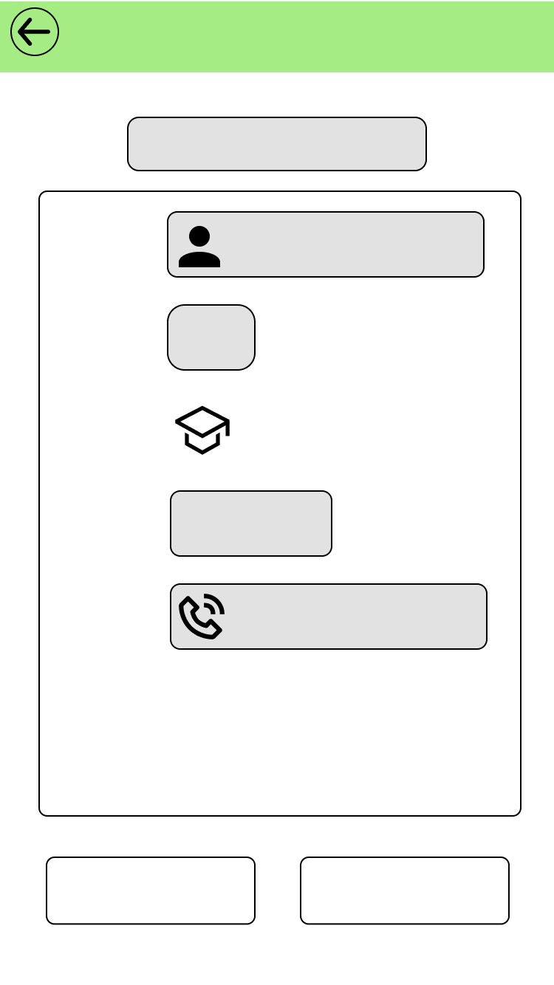

|  |
| --- |
| 台科貓貓募資救援 |

|  |
| --- |
| 王小明 |

|  |
| --- |
| 姓名 : |

|  |
| --- |
| 資訊管理系 |

|  |
| --- |
| 系別 : |

|  |
| --- |
| 台科 |

|  |
| --- |
| 校別 : |

|  |
| --- |
| 0912-345-678 |

|  |
| --- |
| 電話 : |

|  |
| --- |
| 三年級 |

|  |
| --- |
| 年級 : |

|  |
| --- |
| 修改資料 |

|  |
| --- |
| 確認送出 |

|  |
| --- |
| 活動報名 |

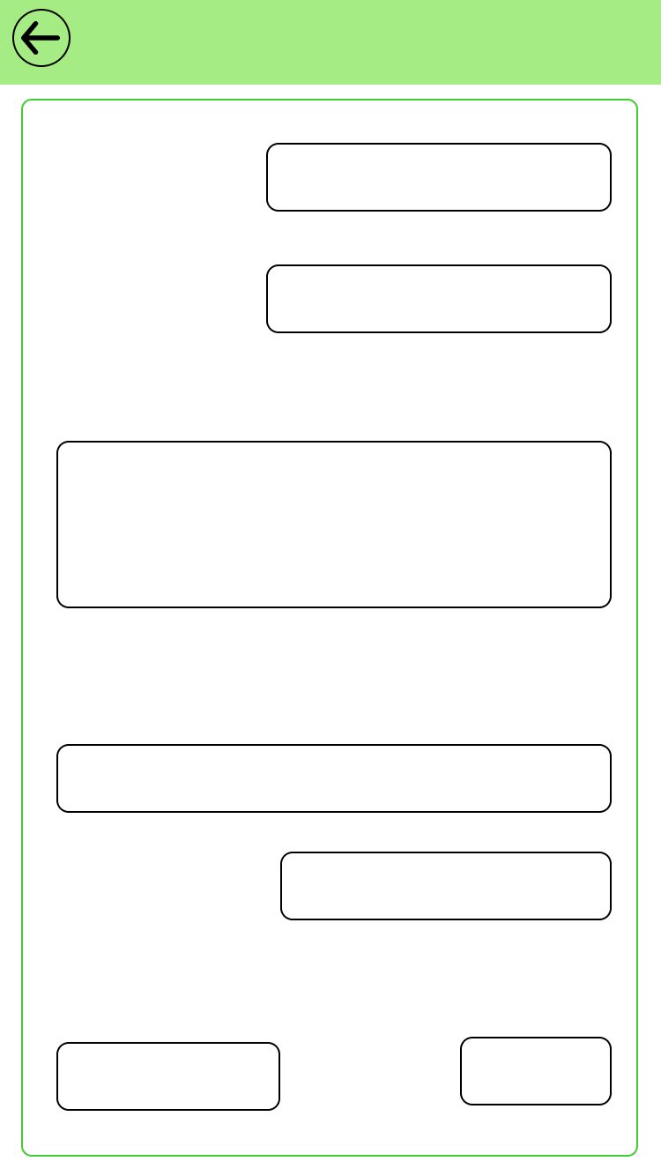

|  |
| --- |
| 修改問卷 |

|  |
| --- |
| 問卷名稱 : |

|  |
| --- |
| 問卷連結 : |

|  |
| --- |
| 文字敘述 : |

|  |
| --- |
| 填寫時間 : |

|  |
| --- |
| 上傳圖片(限制2MB) |

|  |
| --- |
| 問卷限制( 未提供篩選 ) : |

|  |
| --- |
| 完成 |

|  |
| --- |
| 點我上傳 |

|  |
| --- |
| 必填 |

|  |
| --- |
| 必填 |



|  |
| --- |
| 發布問卷 |

|  |
| --- |
| 問卷名稱 : |

|  |
| --- |
| 問卷連結 : |

|  |
| --- |
| 文字敘述 : |

|  |
| --- |
| 填寫時間 : |

|  |
| --- |
| 上傳圖片(限制2MB) |

|  |
| --- |
| 問卷限制( 未提供篩選 ) : |

|  |
| --- |
| 發布 |

|  |
| --- |
| 點我上傳 |

|  |
| --- |
| 必填 |

|  |
| --- |
| 必填 |

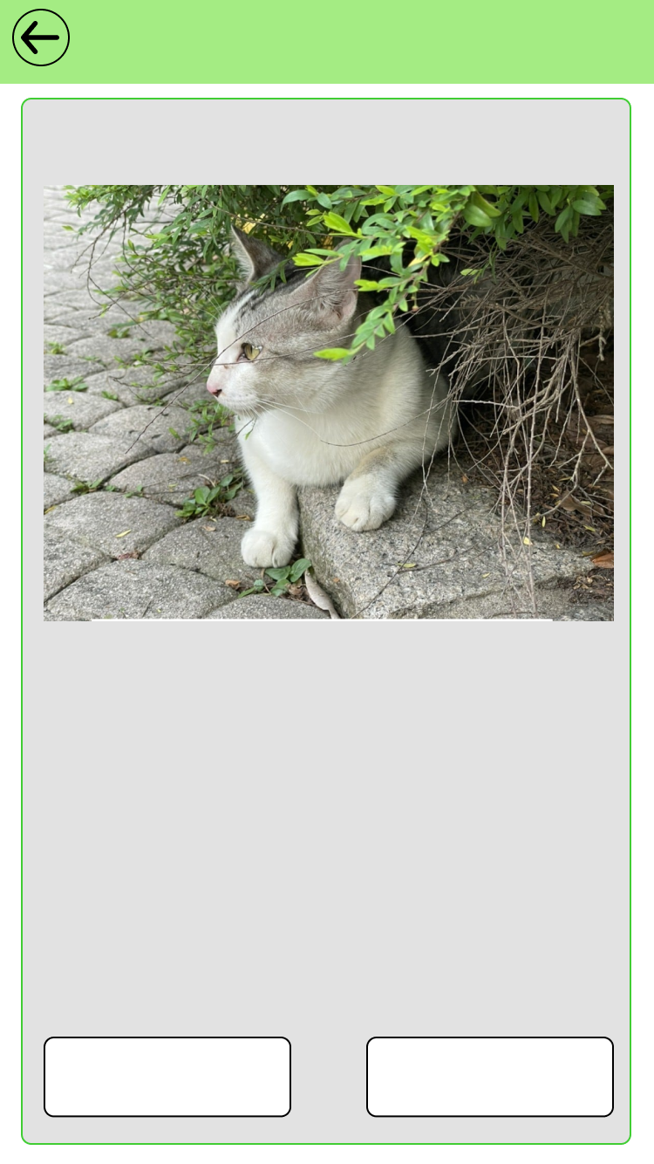

|  |
| --- |
| 發布問卷 ( 預期 ) |

|  |
| --- |
| 台科專題問卷 |

|  |
| --- |
| 這個問卷是關於台科的專題問卷  我不知道其他要打甚麼OWO  反正填完會抽上面這一隻貓貓 |

|  |
| --- |
| 問卷限制 : 限男性  填寫時間:2分鐘 |

|  |
| --- |
| 確認發布 |

|  |
| --- |
| 修改問卷 |

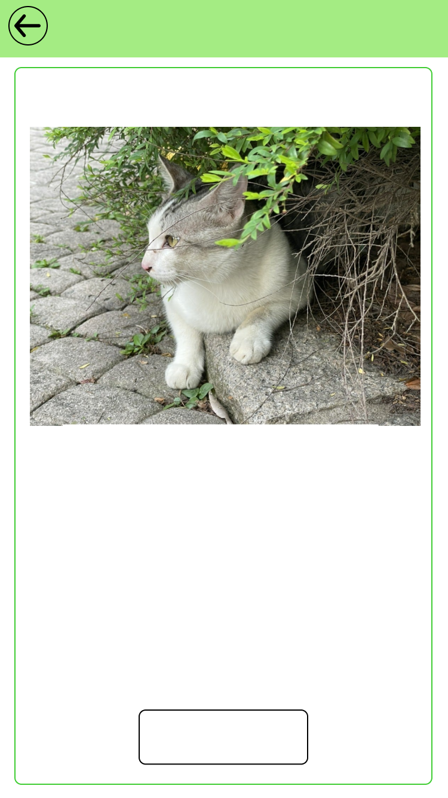

|  |
| --- |
| 問卷填寫 |

|  |
| --- |
| 台科專題問卷 |

|  |
| --- |
| 這個問卷是關於台科的專題問卷  我不知道其他要打甚麼OWO  反正填完會抽上面這一隻貓貓 |

|  |
| --- |
| 問卷限制 : 限男性  填寫時間:2分鐘 |

|  |
| --- |
| 填寫問卷 |

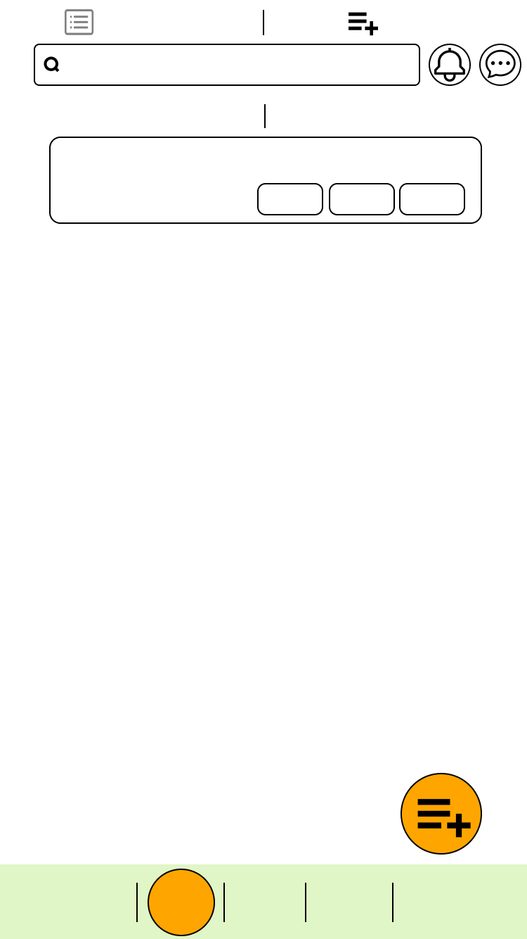

|  |
| --- |
| 抽獎 |

|  |
| --- |
| 問卷 |

|  |
| --- |
| 首頁 |

|  |
| --- |
| 活動 |

|  |
| --- |
| 我的 |

|  |
| --- |
| 請輸入關鍵字 |

|  |
| --- |
| 問卷列表 |

|  |
| --- |
| 問卷管理 |

|  |
| --- |
| 已發布問卷 |

|  |
| --- |
| 已結束問卷 |

|  |
| --- |
| 台科專題問卷 |

|  |
| --- |
| B10809025 / 張三 |

|  |
| --- |
| #抽獎#2分鐘#限男 |

|  |
| --- |
| 修改 |

|  |
| --- |
| 結束 |

|  |
| --- |
| 刪除 |

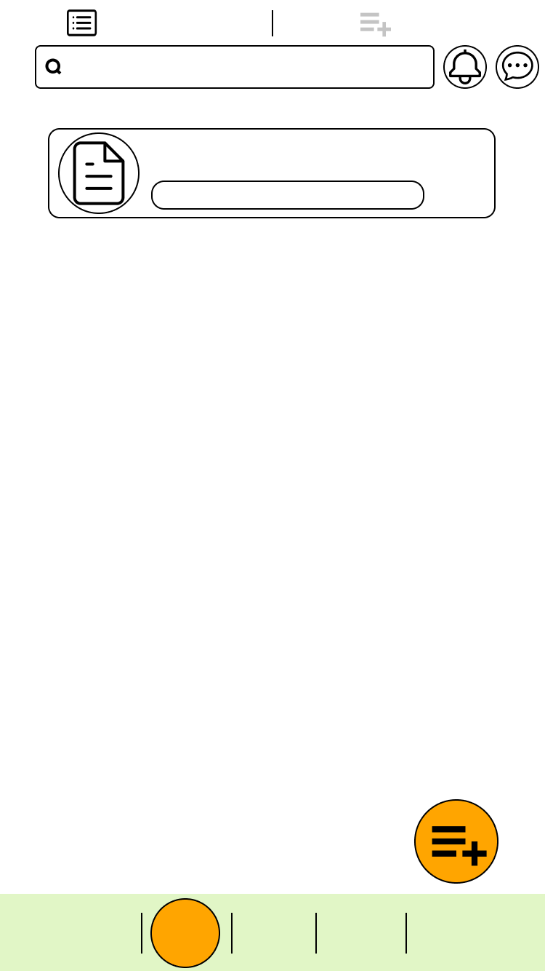

|  |
| --- |
| 抽獎 |

|  |
| --- |
| 問卷 |

|  |
| --- |
| 首頁 |

|  |
| --- |
| 活動 |

|  |
| --- |
| 我的 |

|  |
| --- |
| 請輸入關鍵字 |

|  |
| --- |
| 問卷列表 |

|  |
| --- |
| 問卷管理 |

|  |
| --- |
| 台科專題問卷 |

|  |
| --- |
| #抽獎#2分鐘#限男 |

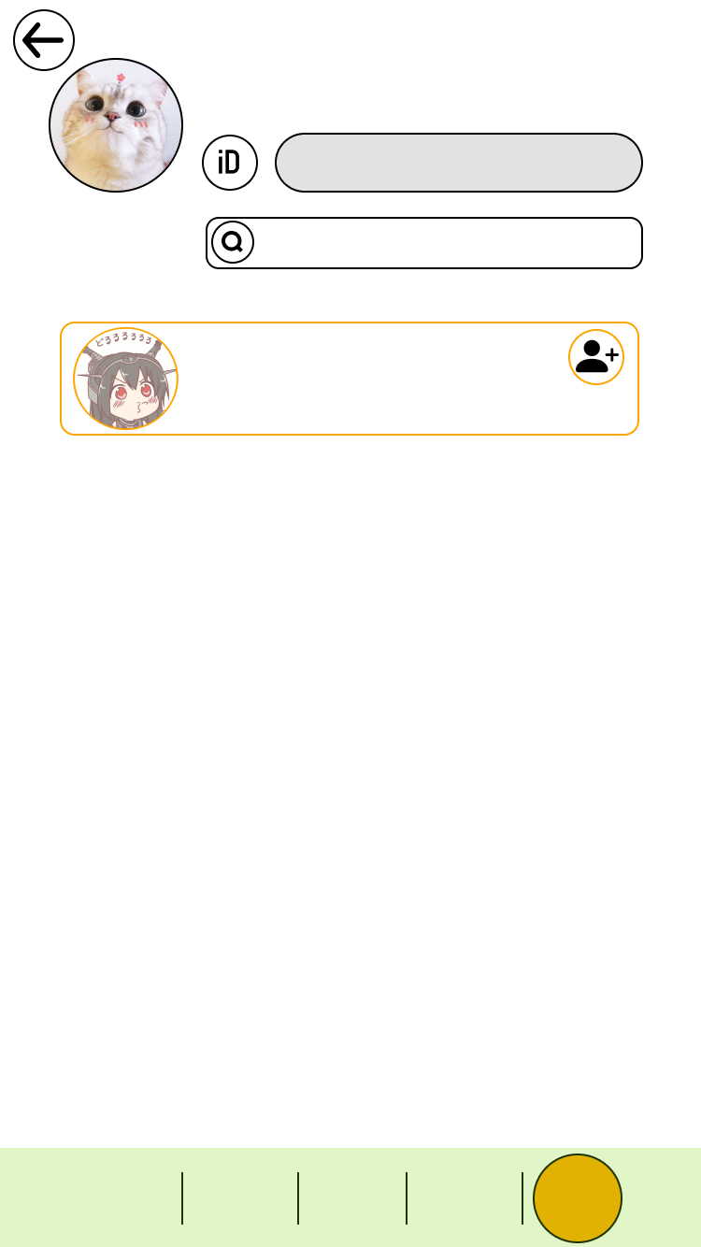

|  |
| --- |
| B10809029 / 薄鹽 |
|  |

|  |
| --- |
| 預設亂數 |

|  |
| --- |
| B10809028 |

|  |
| --- |
| ID / 名稱 : |

|  |
| --- |
| 抽獎 |

|  |
| --- |
| 問卷 |

|  |
| --- |
| 首頁 |

|  |
| --- |
| 活動 |

|  |
| --- |
| 我的 |

|  |
| --- |
| 加號0  B10809028 |

|  |
| --- |
| #台科#資管#學士#男 |

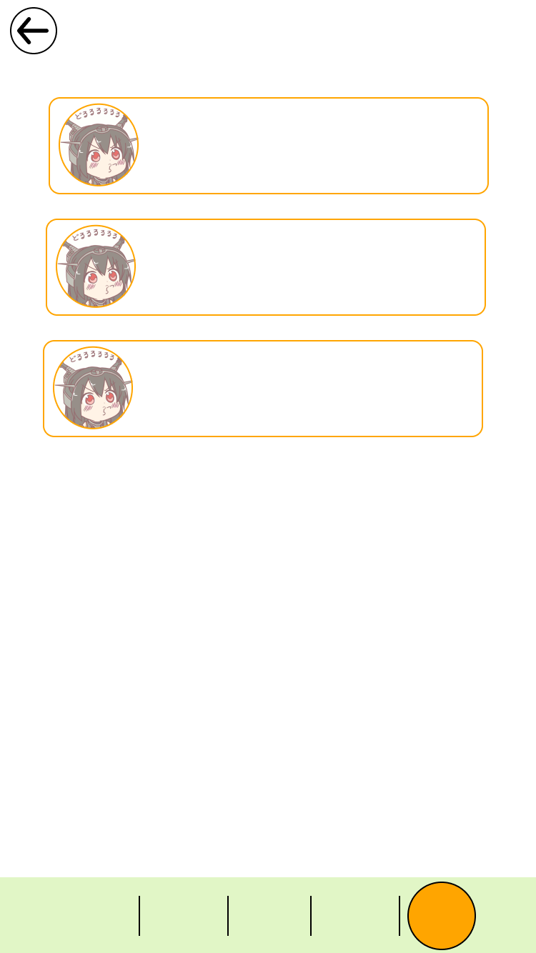

|  |
| --- |
| 抽獎 |

|  |
| --- |
| 問卷 |

|  |
| --- |
| 首頁 |

|  |
| --- |
| 活動 |

|  |
| --- |
| 我的 |

|  |
| --- |
| 聊天室 |

|  |
| --- |
| 10 分鐘前上線 |

|  |
| --- |
| B10809028 / |

|  |
| --- |
| 加號0 |

|  |
| --- |
| #台科#資管#學士#男 |

|  |
| --- |
| 10 分鐘前上線 |

|  |
| --- |
| B10809028 / |

|  |
| --- |
| 加號1 |

|  |
| --- |
| #台科#資管#學士#男 |

|  |
| --- |
| 10 分鐘前上線 |

|  |
| --- |
| B10809028 / |

|  |
| --- |
| 加號2 |

|  |
| --- |
| #台科#資管#學士#男 |

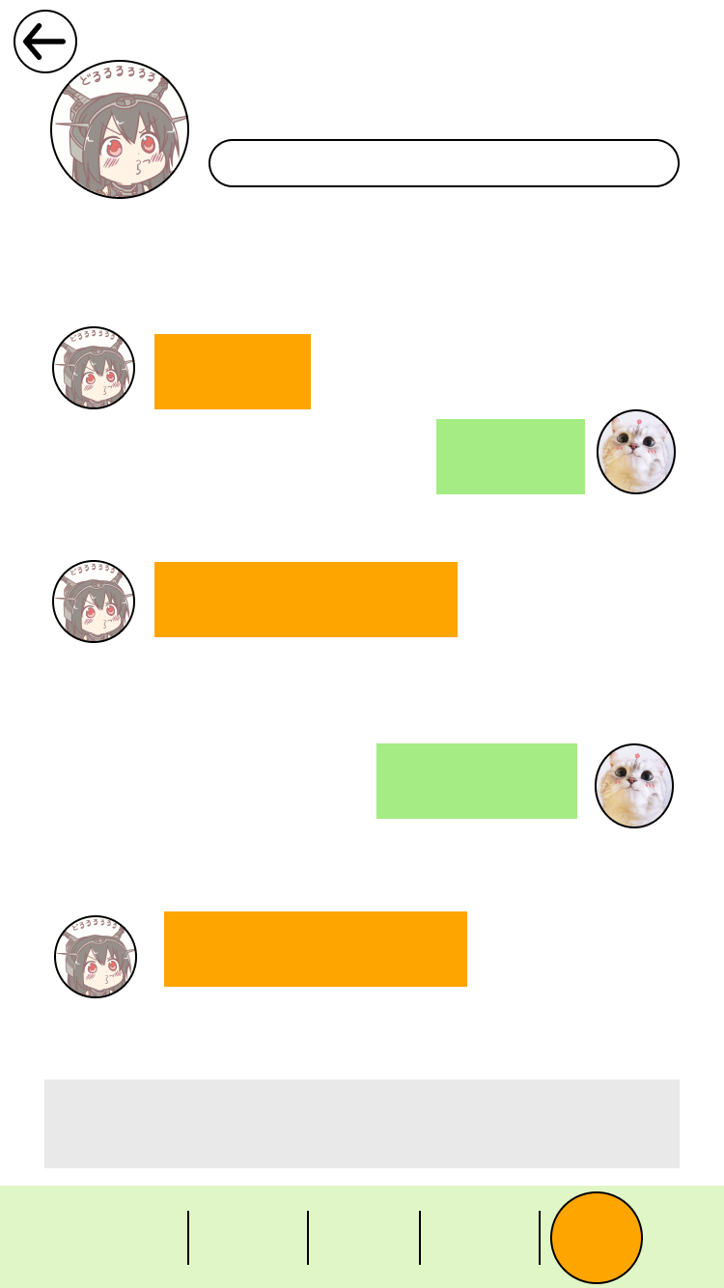

|  |
| --- |
| B10809028 / |

|  |
| --- |
| 加號 |

|  |
| --- |
| #台科#資管#學士#男 |

|  |
| --- |
| 抽獎 |

|  |
| --- |
| 問卷 |

|  |
| --- |
| 首頁 |

|  |
| --- |
| 活動 |

|  |
| --- |
| 我的 |

|  |
| --- |
| 發送訊息...... |

|  |
| --- |
| 安安 |

|  |
| --- |
| 測試? |
| 測試? |

|  |
| --- |
| 你好 |

|  |
| --- |
| 測試發送訊息 |

|  |
| --- |
| 沒啦 騙你的 |

|  |
| --- |
| 15:30 |

|  |
| --- |
| 15:35 |

|  |
| --- |
| 15:30 |

|  |
| --- |
| 15:25 |

|  |
| --- |
| 15:20 |

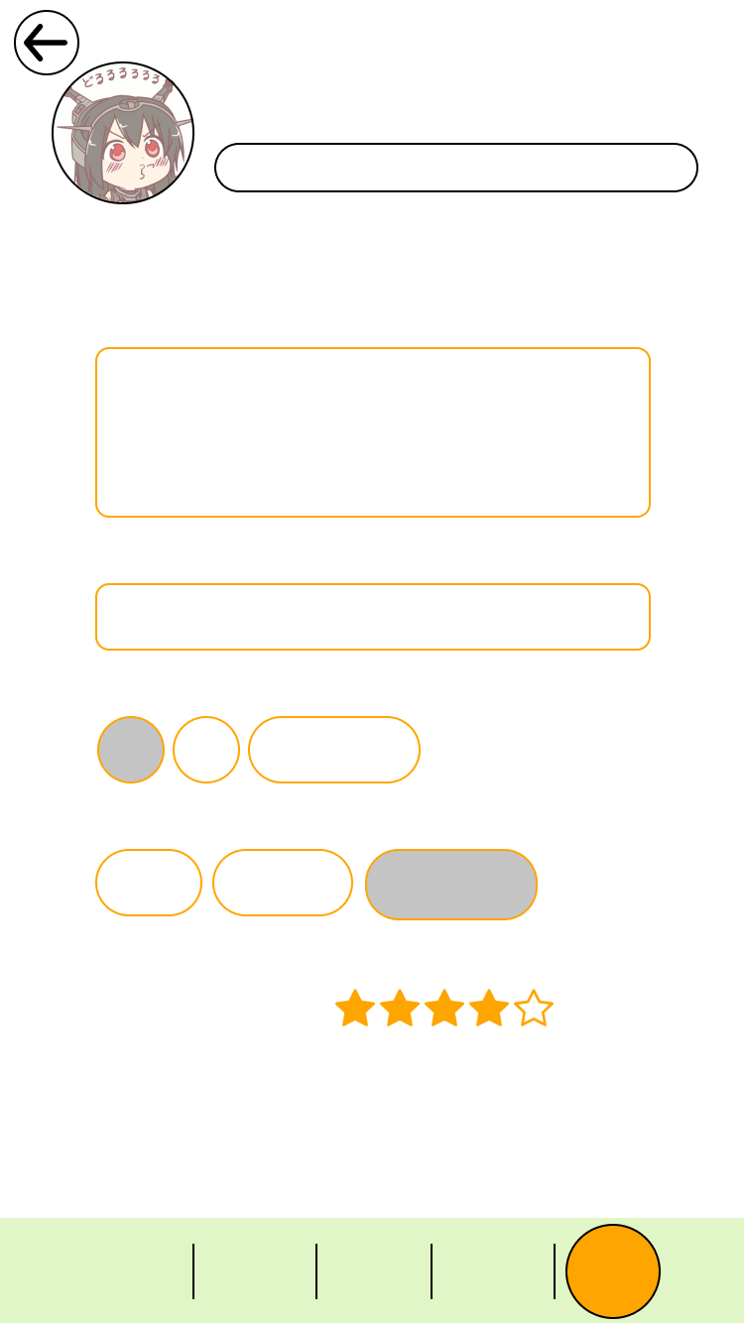

|  |
| --- |
| B10809028 / |

|  |
| --- |
| 加號 |

|  |
| --- |
| #台科#資管#學士#男 |

|  |
| --- |
| 自我介紹 : |

|  |
| --- |
| 你好，交友嗎? |

|  |
| --- |
| 興趣 : |

|  |
| --- |
| 打遊戲 |

|  |
| --- |
| 平均活動評比 : |

|  |
| --- |
| 生理性別 : |

|  |
| --- |
| 男 |

|  |
| --- |
| 女 |

|  |
| --- |
| 關你屁事 |

|  |
| --- |
| 關你屁事 |

|  |
| --- |
| 感情狀況 (OwO_) : |

|  |
| --- |
| 單身 |

|  |
| --- |
| 非單身 |

|  |
| --- |
| 抽獎 |

|  |
| --- |
| 問卷 |

|  |
| --- |
| 首頁 |

|  |
| --- |
| 活動 |

|  |
| --- |
| 我的 |

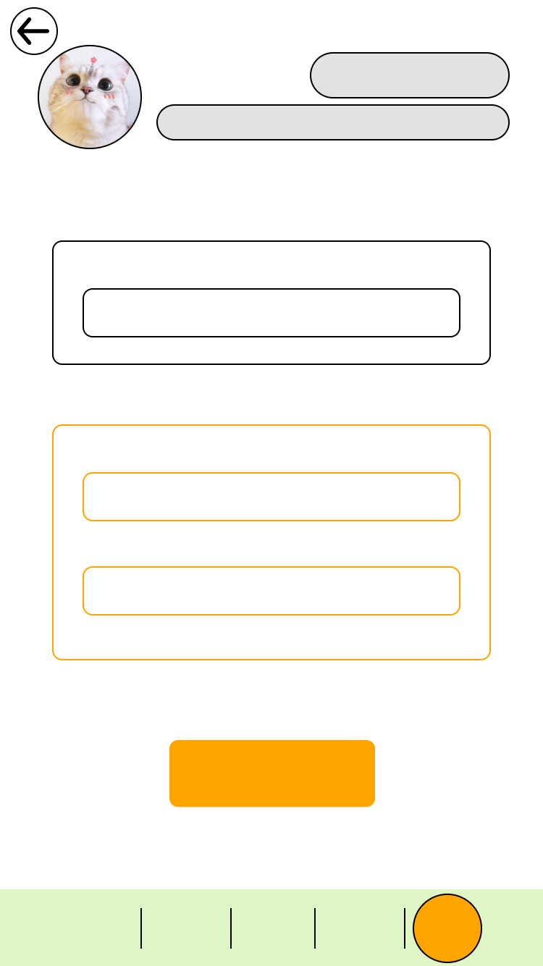

|  |
| --- |
| B10809029 / |

|  |
| --- |
| 薄鹽 |

|  |
| --- |
| #台科#資管#學士#男 |

|  |
| --- |
| 完成 |

|  |
| --- |
| 抽獎 |

|  |
| --- |
| 問卷 |

|  |
| --- |
| 首頁 |

|  |
| --- |
| 活動 |

|  |
| --- |
| 我的 |

|  |
| --- |
| 填入新密碼 : |

|  |
| --- |
| 填入舊密碼 : |

|  |
| --- |
| 再次確認新密碼 : |

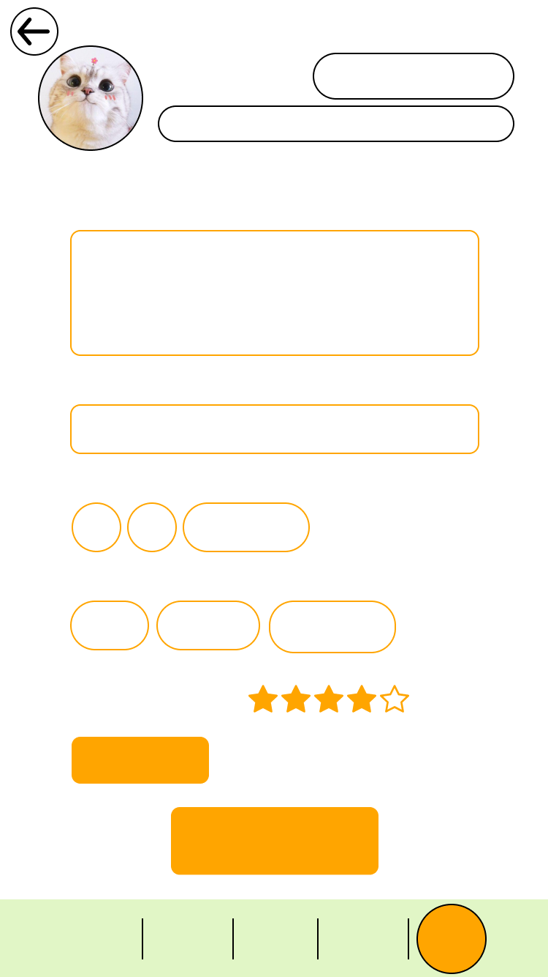

|  |
| --- |
| B10809029 / |

|  |
| --- |
| 薄鹽 |

|  |
| --- |
| #台科#資管#學士#男 |

|  |
| --- |
| 完成設定 |

|  |
| --- |
| 自我介紹 : |

|  |
| --- |
| 非必填 |

|  |
| --- |
| 興趣 : |

|  |
| --- |
| 非必填 |

|  |
| --- |
| 平均活動評比 : |

|  |
| --- |
| 生理性別 : |

|  |
| --- |
| 男 |

|  |
| --- |
| 女 |

|  |
| --- |
| 關你屁事 |

|  |
| --- |
| 關你屁事 |

|  |
| --- |
| 感情狀況 (OwO_) : |

|  |
| --- |
| 單身 |

|  |
| --- |
| 非單身 |

|  |
| --- |
| 抽獎 |

|  |
| --- |
| 問卷 |

|  |
| --- |
| 首頁 |

|  |
| --- |
| 活動 |

|  |
| --- |
| 我的 |

|  |
| --- |
| #姓名限改兩次 |

|  |
| --- |
| 更改密碼 |

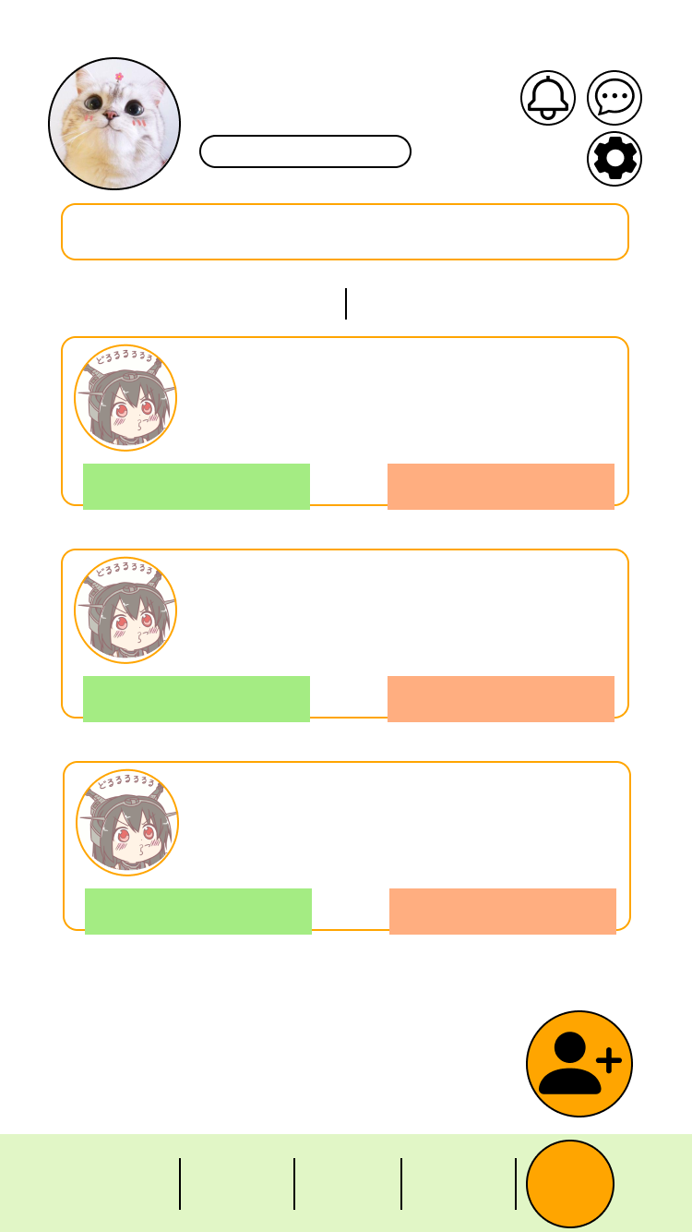

|  |
| --- |
| B10809029 / 薄鹽 |

|  |
| --- |
| #台科#資管#學士#男 |

|  |
| --- |
| 抽獎 |

|  |
| --- |
| 問卷 |

|  |
| --- |
| 首頁 |

|  |
| --- |
| 活動 |

|  |
| --- |
| 我的 |

|  |
| --- |
| 加號0  B10809028 |

|  |
| --- |
| #台科#資管#學士#男 |

|  |
| --- |
| 拒 絕 |

|  |
| --- |
| 接 受 |

|  |
| --- |
| 加號0  B10809028 |

|  |
| --- |
| #台科#資管#學士#男 |

|  |
| --- |
| 拒 絕 |

|  |
| --- |
| 接 受 |

|  |
| --- |
| 加號0  B10809028 |

|  |
| --- |
| #台科#資管#學士#男 |

|  |
| --- |
| 拒 絕 |

|  |
| --- |
| 接 受 |

|  |
| --- |
| 參加過的活動: |

|  |
| --- |
| 在活動中認識了 30 個朋友 |

|  |
| --- |
| 20場 |

|  |
| --- |
| 好友列 |

|  |
| --- |
| 待確認好友列 |

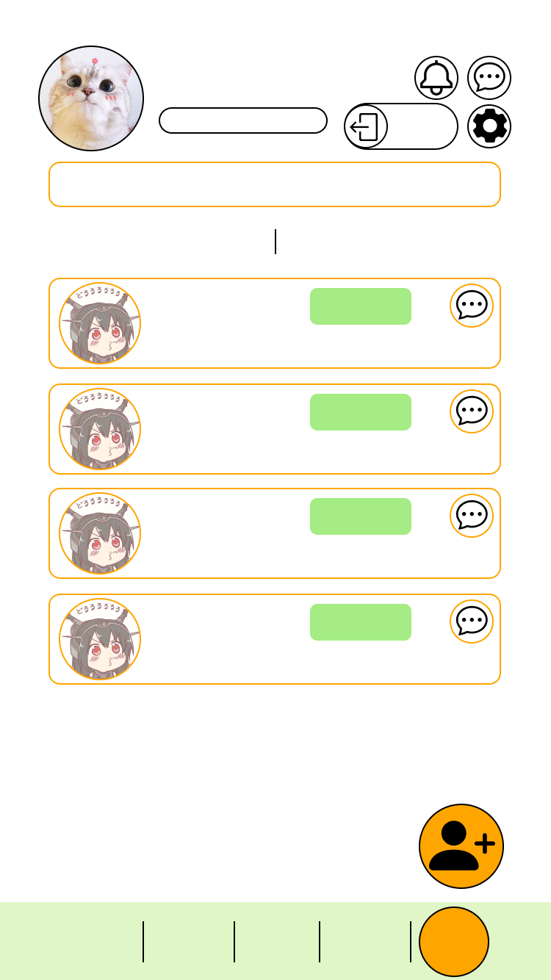

|  |
| --- |
| B10809029 / 薄鹽 |
|  |

|  |
| --- |
| #台科#資管#學士#男 |

|  |
| --- |
| 好友列 |

|  |
| --- |
| 待確認好友列 |

|  |
| --- |
| 加號2  B10809028 |

|  |
| --- |
| #台科#資管#學士#男 |

|  |
| --- |
| 加號3  B10809028 |

|  |
| --- |
| #台科#資管#學士#男 |

|  |
| --- |
| 加號0  B10809028 |

|  |
| --- |
| #台科#資管#學士#男 |

|  |
| --- |
| 加號1  B10809028 |

|  |
| --- |
| #台科#資管#學士#男 |

|  |
| --- |
| 抽獎 |

|  |
| --- |
| 問卷 |

|  |
| --- |
| 首頁 |

|  |
| --- |
| 活動 |

|  |
| --- |
| 我的 |

|  |
| --- |
| 參加過的活動: |

|  |
| --- |
| 在活動中認識了 30 個朋友 |

|  |
| --- |
| 20場 |

|  |
| --- |
| 刪除好友 |

|  |
| --- |
| 刪除好友 |

|  |
| --- |
| 刪除好友 |

|  |
| --- |
| 刪除好友 |

|  |
| --- |
| 登出 |

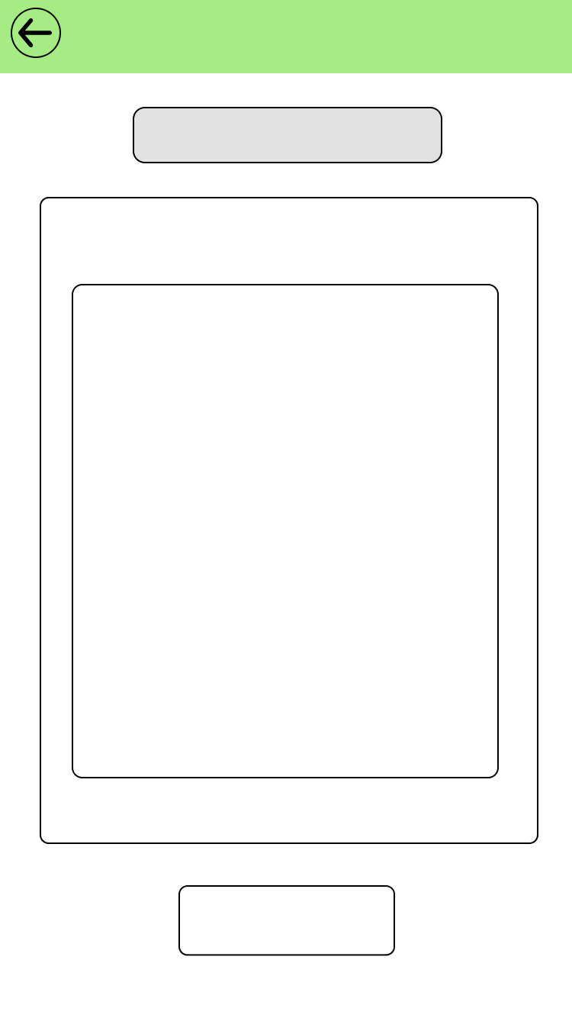

|  |
| --- |
| 台科貓貓募資救援 |

|  |
| --- |
| 非必填 |

|  |
| --- |
| 取消原因 : |

|  |
| --- |
| #取消後無法再次加入相同活動 |

|  |
| --- |
| 確認取消 |

|  |
| --- |
| 取消報名 |

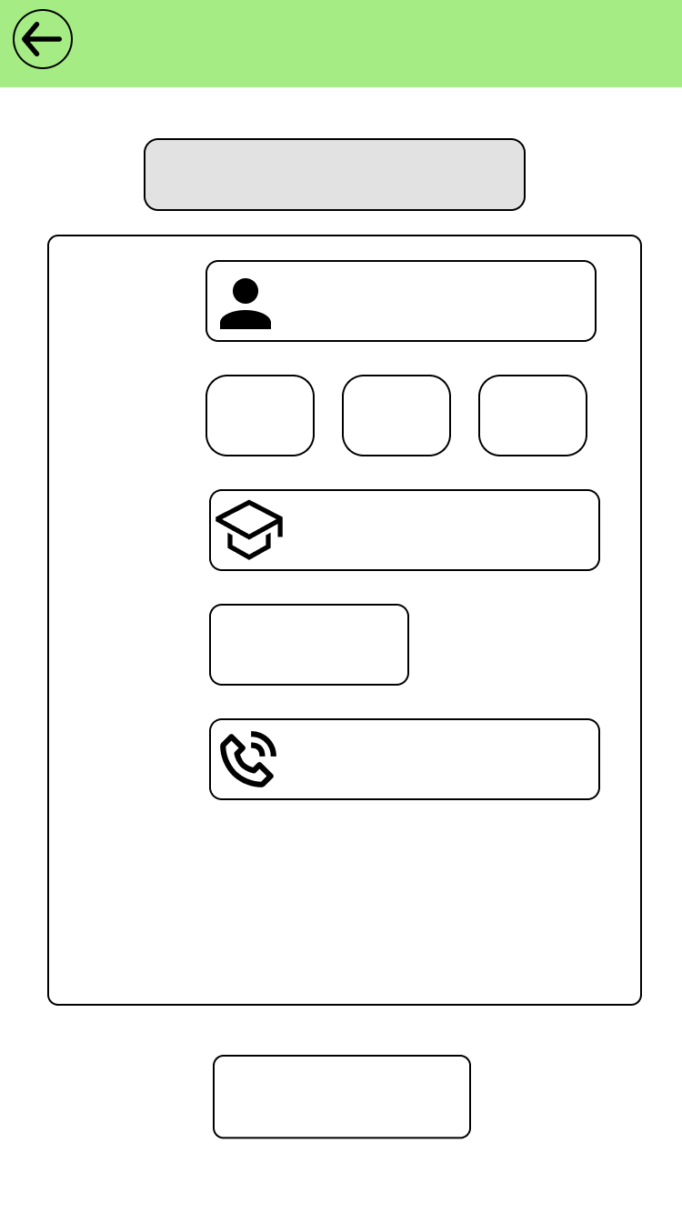

|  |
| --- |
| 台科貓貓募資救援 |

|  |
| --- |
| 自動填入 |

|  |
| --- |
| 姓名 : |

|  |
| --- |
| 自動填入 |

|  |
| --- |
| 系別 : |

|  |
| --- |
| 台科 |

|  |
| --- |
| 校別 : |

|  |
| --- |
| 台師 |

|  |
| --- |
| 台大 |

|  |
| --- |
| xxx-xxx-xxx |

|  |
| --- |
| 電話 : |

|  |
| --- |
| 自動填入 |

|  |
| --- |
| 年級 : |

|  |
| --- |
| 報名活動 |

|  |
| --- |
| 活動報名 |

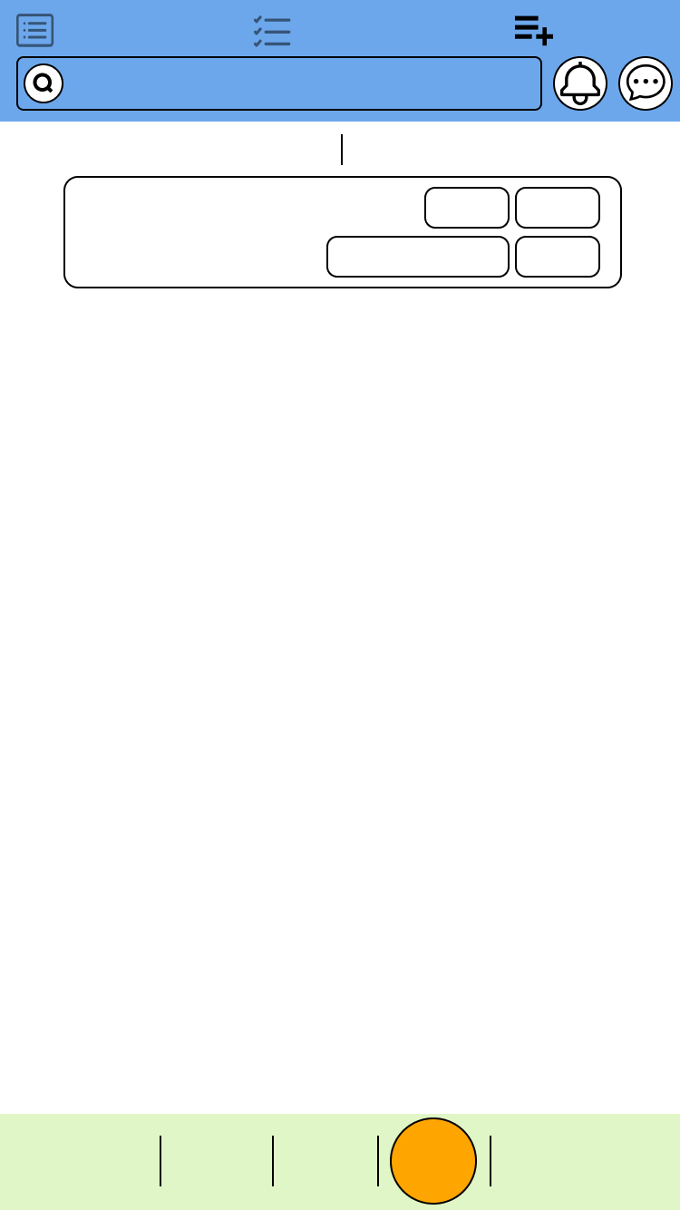

|  |
| --- |
| 活動列表 |

|  |
| --- |
| 已報名活動 |

|  |
| --- |
| 活動管理 |

|  |
| --- |
| 請輸入關鍵字 |

|  |
| --- |
| 已發布活動 |

|  |
| --- |
| 已結束活動 |

|  |
| --- |
| 資管宿營 |

|  |
| --- |
| 台科資管系學會 |

|  |
| --- |
| #系務#台科 |

|  |
| --- |
| 報名者管理 |

|  |
| --- |
| 修改 |

|  |
| --- |
| 刪除 |

|  |
| --- |
| 詳細 |

|  |
| --- |
| 抽獎 |

|  |
| --- |
| 問卷 |

|  |
| --- |
| 首頁 |

|  |
| --- |
| 活動 |

|  |
| --- |
| 我的 |

|  |
| --- |
| 抽獎 |

|  |
| --- |
| 問卷 |

|  |
| --- |
| 首頁 |

|  |
| --- |
| 我的 |

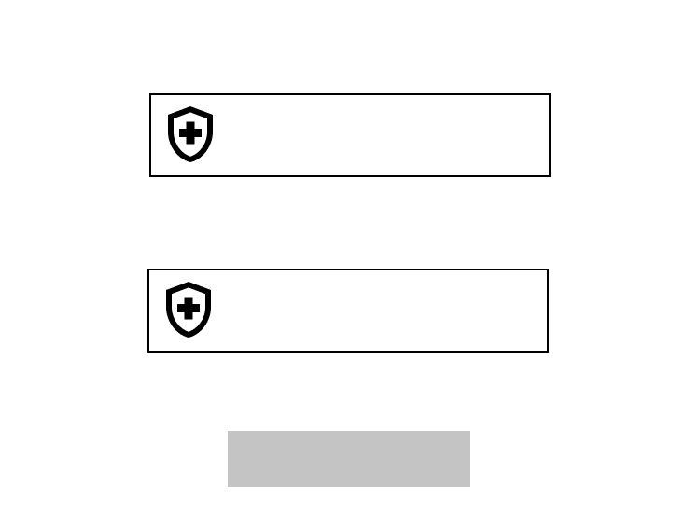

|  |
| --- |
| 設定密碼 : |

|  |
| --- |
| 確認 |

|  |
| --- |
| 設定密碼 : |

|  |
| --- |
| XXX-XXX-XXX |

|  |
| --- |
| XXX-XXX-XXX |

|  |
| --- |
| 再次輸入密碼 : |

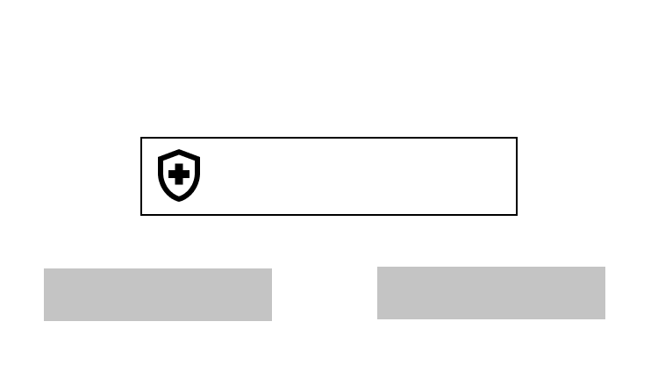

|  |
| --- |
| 驗證碼 : |

|  |
| --- |
| 000-000 |

|  |
| --- |
| 確認 |

|  |
| --- |
| 重寄驗證碼 |

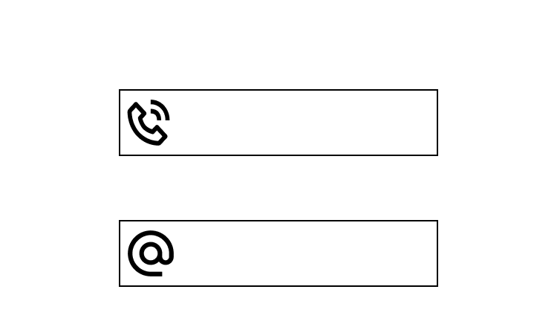

|  |
| --- |
| XXX-XXX-XXX |

|  |
| --- |
| 客服郵件 : |

|  |
| --- |
| 客服電話 : |

|  |
| --- |
| example.gmail.com |



|  |
| --- |
| 返回 |

|  |
| --- |
| 感謝您的註冊，  請至學校信箱收取驗證碼  後重新登入 |

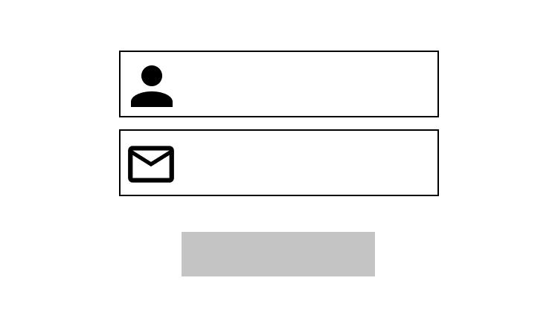

|  |
| --- |
| 學號 |

|  |
| --- |
| 電子郵件 |

|  |
| --- |
| 發送驗證碼 |

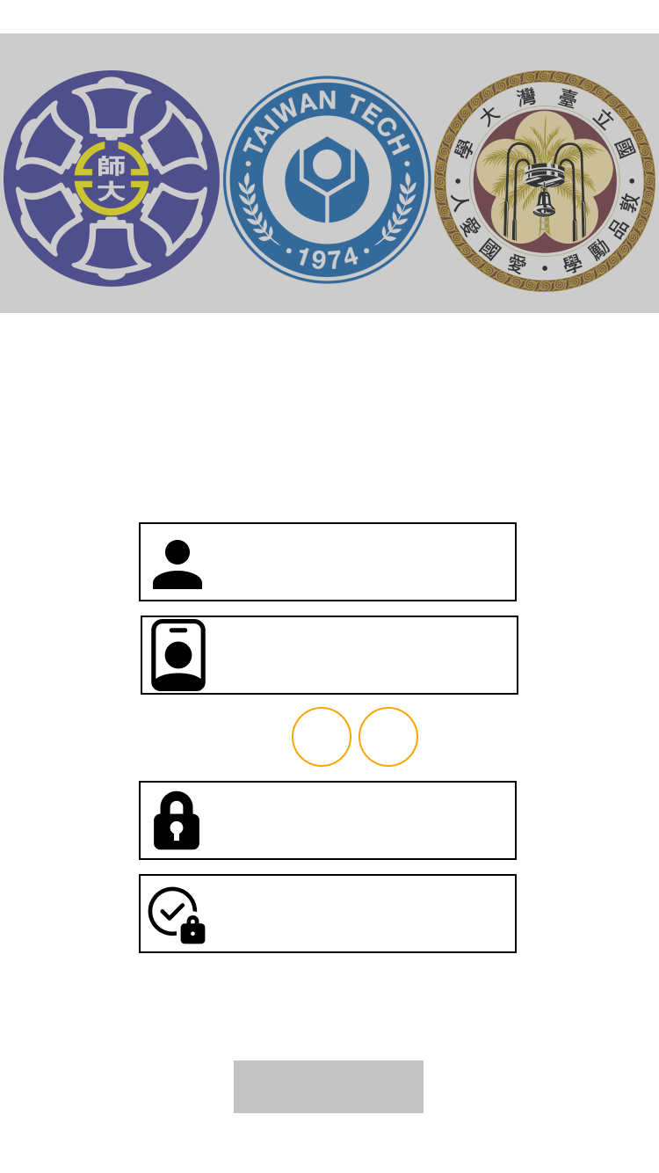

|  |
| --- |
| (驗證碼將傳送至學校信箱) |

|  |
| --- |
| 學號 |

|  |
| --- |
| 密碼 |

|  |
| --- |
| 確認密碼 |

|  |
| --- |
| 確認註冊 |

|  |
| --- |
| 拓展你的三校視野 |

|  |
| --- |
| 三校活動交友平台 |

|  |
| --- |
| 姓名 |

|  |
| --- |
| 生理性別 : |

|  |
| --- |
| 男 |

|  |
| --- |
| 女 |

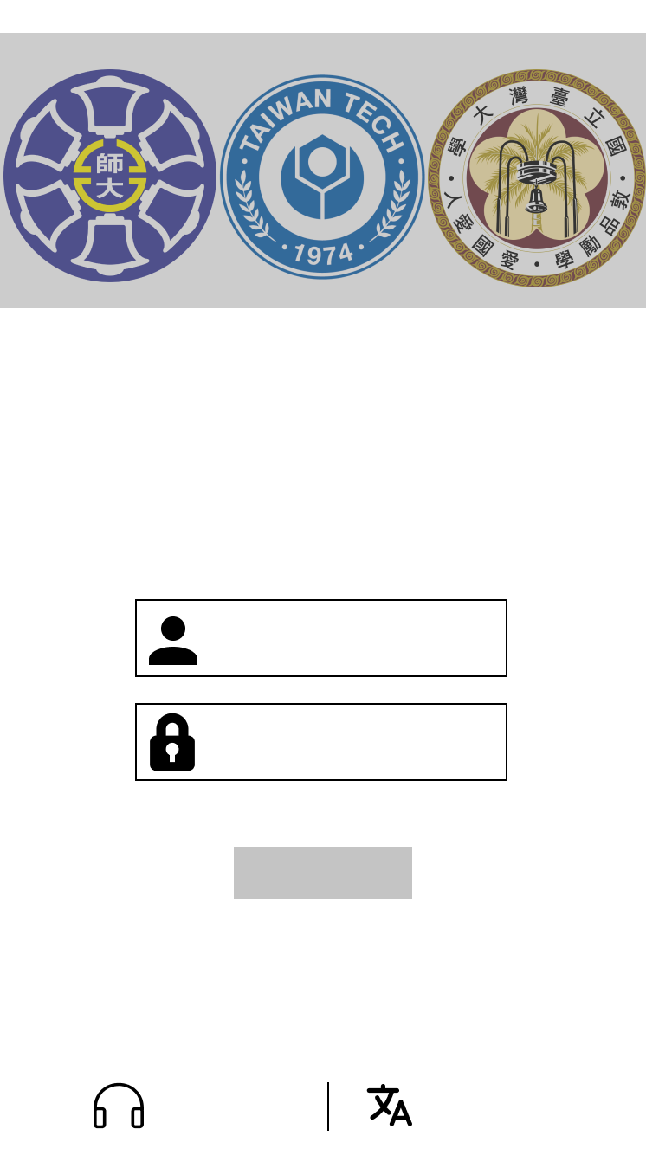

|  |
| --- |
| 登入 |

|  |
| --- |
| 學號 |

|  |
| --- |
| 第一次使用嗎? 按此註冊 |

|  |
| --- |
| 聯絡客服 |

|  |
| --- |
| 忘記密碼 |

|  |
| --- |
| 密碼 |

|  |
| --- |
| 拓展你的三校視野 |

|  |
| --- |
| 三校活動交友平台 |

|  |
| --- |
| 切換語言 |